Sr. No. | Chapter / Section | Page No.
1 | Introduction | 2
2 | Problem Statement & Objectives | 4
3 | Project Scope & Use Case | 5
4 | Technology & Tools Used | 7
5 | System Architecture & Methodology | 10
6 | Dataset Collection & Understanding | 12
7 | Exploratory Data Analysis (EDA) | 14
8 | Data Cleaning & NLP Preprocessing | 18
9 | Skill Taxonomy Development | 21
10 | Rule-Based Skill Extraction | 23
11 | Statistical & Semantic NLP Techniques | 25
12 | Named Entity Recognition (NER) | 27
13 | Machine Learning Model Training | 29
14 | Transformer-Based Model | 31
15 | Model Evaluation & Comparison | 33
16 | Error Analysis | 35
17 | Skill Normalization & Categorization | 37
18 | Dashboard & Data Visualization | 39
19 | Application / API Development | 41
20 | Testing & Results | 43
21 | Challenges & Limitations | 45
22 | Conclusion | 46
23 | Future Scope | 47
24 | Internship Learning Outcomes | 48
25 | References | 50
* INDEX *
1.INTRODUCTION

1.1 Project Background
The rapid growth of the information technology and employment sectors has resulted in a large number of job opportunities and an increasing volume of job descriptions published on online recruitment platforms. A job description generally contains information about the job role, required technical skills, soft skills, educational qualifications, experience, tools, technologies, and other candidate requirements. Identifying the important skills from these descriptions manually can be time-consuming and may lead to inconsistent results.
The SkillSense – Intelligent Job Skill Analysis project is developed to automate the analysis of job descriptions and identify the skills required for a particular job role. The system uses Natural Language Processing (NLP) techniques to process unstructured job-description text and extract relevant skills. The extracted information can help users understand the skill requirements of a job more efficiently.
The project focuses on converting unstructured textual information into structured and meaningful skill information. This can support applications such as job analysis, skill-gap identification, candidate profiling, recruitment assistance, and career planning.

1.2 Overview of Natural Language Processing
Natural Language Processing (NLP) is a branch of Artificial Intelligence (AI) that enables computers to understand, process, and analyze human language. Since textual data is generally unstructured, NLP techniques are used to transform natural-language text into a form that can be processed by machine learning and deep learning models.
NLP is widely used in applications such as text classification, sentiment analysis, machine translation, information extraction, question answering, chatbots, and named entity recognition. Common NLP preprocessing operations include tokenization, text normalization, stop-word handling, and linguistic analysis.
For the SkillSense project, NLP provides the foundation for understanding job-description text. Instead of treating the job description as simple text, the system analyzes the words and phrases to identify entities that represent relevant skills and technologies.

1.3 Job-Skill Extraction Concept
Job-skill extraction is the process of automatically identifying skills and competencies mentioned in a job description. These skills may include programming languages, frameworks, databases, cloud technologies, software tools, methodologies, and other professional competencies.
For example, a job description may contain the following statement:
"The candidate should have experience in Python, SQL, Machine Learning, and TensorFlow."
From this text, a skill extraction system can identify:
- Python
- SQL
- Machine Learning
- TensorFlow
Traditional keyword-based approaches can identify predefined terms, but they may have difficulty understanding skills expressed in different contexts or formats. NLP and machine learning-based approaches can provide a more intelligent method for identifying skill-related entities from unstructured text.
In this project, Named Entity Recognition (NER) is used as an important technique for identifying skill entities from job descriptions. A fine-tuned DistilBERT-based NER model can analyze the contextual meaning of words and phrases and classify relevant portions of the text as skill-related entities.
1.4 Role of NLP in SkillSense
The SkillSense system applies NLP to transform a raw job description into useful structured information. The general workflow consists of accepting the job description as input, processing the text, identifying relevant skill entities using the trained NLP model, and presenting the extracted skills to the user.
The basic process can be represented as:
Job Description → Text Processing → NLP Model → Skill Extraction → Structured Skill Output
This approach reduces the need for manual examination of lengthy job descriptions and provides a consistent method for identifying the skills required for different job roles.

1.5 Need for the Project
The project is motivated by the following requirements:
- Automation: Reduce the effort required to manually identify skills from job descriptions.
- Efficient Analysis: Process large amounts of job-description text quickly.
- Contextual Understanding: Use NLP models to identify skills based on their context rather than relying only on simple keyword matching.
- Structured Information: Convert unstructured job descriptions into an organized list of relevant skills.
- Recruitment Support: Assist in understanding the technical and professional requirements of job roles.
- Career Support: Help users identify the skills expected for specific job positions.

1.6 Project Objective
The primary objective of the SkillSense project is to develop an intelligent NLP-based system that can automatically analyze job descriptions and extract relevant skills. The system aims to provide accurate and structured skill information from unstructured job-description text, thereby making job-skill analysis faster, easier, and more consistent.

2. PROBLEM STATEMENT & OBJECTIVES
2.1 Problem Statement
Job descriptions available on recruitment platforms are generally written in unstructured natural language and contain a mixture of technical skills, soft skills, qualifications, experience requirements, tools, and other information. Extracting the relevant skills manually from these descriptions is time-consuming and may result in missed or incorrectly identified skills.
Traditional keyword-based approaches also have limitations because the same skill may appear in different forms or contexts. Therefore, there is a need for an intelligent system that can automatically process job-description text, understand its context, and identify relevant skills.
The SkillSense – Intelligent Job Skill Analysis project addresses this problem by developing an NLP-based system that analyzes job descriptions and automatically extracts relevant skills using a trained Named Entity Recognition (NER) model.
2.2 Business Objective
The primary business objective of SkillSense is to simplify and automate the analysis of job descriptions.
The system aims to:
- Reduce the time required to identify skills from job descriptions.
- Provide a structured representation of required job skills.
- Support recruiters in understanding skill requirements more efficiently.
- Help organizations analyze skill requirements across different job roles.
- Assist candidates in understanding the technical and professional skills expected for a particular position.
- Reduce dependency on completely manual job-description analysis.
2.3 Technical Objective
The technical objectives of the project are:
- To develop an NLP-based application for job-description analysis.
- To preprocess and analyze unstructured job-description text.
- To identify relevant skill entities from the input text.
- To implement a Named Entity Recognition (NER) approach for skill extraction.
- To utilize a fine-tuned DistilBERT-based NER model for contextual skill identification.
- To integrate the trained NLP model with a user-friendly web application.
- To display the extracted skills in a structured and understandable format.
- To evaluate the performance of the skill extraction model using standard evaluation metrics such as Precision, Recall, and F1-Score.
2.4 Expected Outcome
The expected outcome of the project is a functional intelligent job-skill analysis system that accepts a job description as input and automatically identifies relevant skills.
The system is expected to:
- Accept unstructured job-description text from the user.
- Process the input using NLP techniques.
- Detect skill-related entities using the trained NER model.
- Extract and organize the identified skills.
- Present the results through a web-based interface.
Provide a faster and more consistent alternative to manual skill identification.
The final system demonstrates how NLP and transformer-based models can be applied to real-world recruitment and job-market data to convert unstructured job descriptions into meaningful structured skill information.
3. PROJECT SCOPE & USE CASE
3.1 Project Scope
The scope of the SkillSense – Intelligent Job Skill Analysis project is to develop an NLP-based system that can analyze unstructured job descriptions and automatically extract relevant skills. The system focuses primarily on identifying technical and professional skills mentioned in job-description text using a trained Named Entity Recognition (NER) model.
The project covers the complete process from receiving job-description text as input to presenting the extracted skills as structured output. It combines Natural Language Processing, transformer-based language models, and a web-based interface to provide an easy-to-use job-skill analysis solution.
The major areas included within the project scope are:
- Collection and preparation of job-description text.
- Text preprocessing and NLP-based text analysis.
- Identification of skill-related entities.
- Fine-tuning and utilization of a DistilBERT-based NER model.
- Automatic extraction of skills from job descriptions.
- Integration of the NLP model with a web application.
- Display of extracted skills in a structured format.
- Evaluation of the skill extraction model using Precision, Recall, and F1-Score.
The current scope is focused on job-skill extraction from job descriptions. It does not aim to replace complete recruitment processes such as candidate interviews, background verification, final hiring decisions, or employee performance evaluation.

3.2 Recruitment Use Case
SkillSense can be used as an assisting tool in the recruitment process. Recruiters often need to examine multiple job descriptions to understand the skills required for different positions. The proposed system can automate the initial skill-identification stage.
A typical recruitment use case is:
Job Description → SkillSense → NLP Processing → Skill Extraction → Structured Skill List → Recruiter Analysis
For example, when a recruiter provides a job description containing requirements such as Python, SQL, Machine Learning, TensorFlow, and communication skills, SkillSense analyzes the text and extracts the relevant skill entities.
The recruiter can then use the extracted information to:
- Understand the core skills required for the position.
- Prepare or refine job descriptions.
- Compare skill requirements across different roles.
- Support candidate skill matching.
- Identify frequently requested technologies.
- Reduce the time spent manually reviewing job descriptions.
The system therefore acts as a decision-support and job-analysis tool, rather than making the final recruitment decision.

3.3 Practical Applications
The SkillSense system can have several practical applications in recruitment and career-oriented environments.

3.3.1 Recruitment Assistance
Recruiters can use the system to quickly identify the important skills associated with a job role and use them during the initial recruitment analysis.
3.3.2 Candidate Skill Matching
Extracted job skills can be compared with candidate resume skills to determine the degree of alignment between a candidate and a job requirement.
3.3.3 Skill Gap Analysis
The extracted skills can help candidates identify which skills they may need to develop for a specific job role.
3.3.4 Job Description Analysis
Organizations can analyze job descriptions to identify the technical skills and competencies most frequently required for particular positions.
3.3.5 Career Planning
Students and job seekers can use extracted skill information to understand the skills expected for their target roles and plan their learning accordingly.
3.3.6 Recruitment Analytics
Aggregated skill-extraction results can potentially be used to identify trends in technology and skill requirements across different job roles and industries.

3.4 Intended Users
The major intended users of SkillSense include:
- Recruiters and HR professionals – for faster job-description analysis.
- Job seekers – for understanding required skills.
- Students and fresh graduates – for identifying industry-relevant skills.
- Career counselors – for supporting skill and career planning.
- Organizations – for analyzing job-role skill requirements.

3.5 Scope Limitations
Although SkillSense provides automated skill extraction, the quality of the output depends on the training data, model performance, and the way skills are expressed in the input job description.
The system is primarily designed for skill extraction and does not independently perform final candidate selection, interviews, salary negotiation, or hiring decisions. Therefore, the extracted results should be considered as supporting information for human decision-making rather than a complete automated recruitment solution.

4. TECHNOLOGY & TOOLS USED
The SkillSense – Intelligent Job Skill Analysis project is developed using Python-based technologies and Natural Language Processing libraries. These tools are used for data preparation, text preprocessing, model development, skill extraction, model evaluation, data visualization, and web application development.
4.1 Python
Python is the primary programming language used for developing the SkillSense system. It provides extensive support for Natural Language Processing, machine learning, data analysis, visualization, and web application development.
Python is used throughout the project for:
- Data preprocessing and manipulation.
- NLP operations.
- Model training and inference.
- Skill extraction.
- Model evaluation.
- Web application integration.
4.2 Pandas
Pandas is a Python library used for data manipulation and analysis. It provides DataFrame-based structures for organizing and processing datasets.
In the SkillSense project, Pandas is used for:
- Loading datasets.
- Handling job-description data.
- Cleaning and preparing data.
- Organizing training and testing data.
- Performing data analysis.
4.3 NumPy
NumPy is a Python library used for numerical computing and array-based operations. It provides efficient numerical data structures and mathematical functions.
In the project, NumPy supports numerical operations required during data processing, machine learning, and evaluation workflows.
4.4 NLTK
Natural Language Toolkit (NLTK) is a Python library used for Natural Language Processing and text processing tasks.
It is used to support operations such as:
- Tokenization.
- Text preprocessing.
- Stop-word handling.
- Basic linguistic analysis.
NLTK helps prepare textual data before further NLP processing.
4.5 spaCy
spaCy is an NLP library designed for efficient processing of natural-language text. It provides tools for tokenization, linguistic processing, and Named Entity Recognition.
In the SkillSense project, spaCy is used for NLP-related text processing and analysis during the development of the skill extraction system.

4.6 Scikit-learn
Scikit-learn is a machine learning library that provides tools for data preprocessing, model evaluation, and statistical analysis.
In the project, Scikit-learn is used for:
- Train-test data splitting.
- Data preprocessing.
- Evaluation of model performance.
- Calculation of Precision, Recall, and F1-Score.
4.7 Transformers
The Transformers library is used to implement transformer-based Natural Language Processing models.
In SkillSense, Transformers is used for the DistilBERT-based Named Entity Recognition (NER) model. The trained model analyzes job-description text and identifies relevant skill entities using contextual language understanding.
The transformer-based approach allows the system to understand the relationship between words and their surrounding context rather than depending only on predefined keywords.
4.8 Matplotlib
Matplotlib is a Python visualization library used to create graphs and charts.
In the SkillSense project, Matplotlib is used for visualizing model performance and analysis results. It can be used to generate graphical representations of evaluation metrics such as:
- Precision.
- Recall.
- F1-Score.
- Model performance comparisons.
These visualizations make it easier to understand and interpret the performance of the developed NLP model.
4.9 Seaborn
Seaborn is a Python data visualization library built on top of Matplotlib. It provides a high-level interface for creating statistical and analytical visualizations.
In the project, Seaborn is used for presenting data-analysis and model-evaluation results in a clear graphical form. It can be used for visualizations such as:
- Performance comparison charts.
- Distribution plots.
- Confusion matrices.
- Statistical analysis of datasets.
Seaborn improves the readability and presentation of analytical results during the model development and evaluation stages.
4.10 Streamlit
Streamlit is a Python framework used to build interactive web applications for data science and machine learning projects.
In SkillSense, Streamlit provides the user interface for the developed NLP system. Through the web application, users can:
- Enter or paste a job description.
- Submit the text for processing.
- Run the trained NLP model.
- Extract relevant skills.
- View the extracted skills in a structured format.
Streamlit connects the trained NLP model with the user-facing application and makes the system easier to use.

4.10 Power BI
Power BI is a business intelligence and data visualization tool used to create interactive dashboards and present analytical results in an easy-to-understand format.
In the SkillSense project, Power BI is used for visualizing skill-related analysis and model results. It can help present information such as skill frequency, skill distribution, job-role requirements, and other extracted-skill insights through interactive charts and dashboards.
Power BI helps convert the extracted and processed data into meaningful visual insights, making the results easier to interpret for recruiters, analysts, and other users.

4.12 Technology Summary
Technology / Tool | Purpose in SkillSense
Python | Core programming and application development
Pandas | Dataset handling and data analysis
NumPy | Numerical and array operations
NLTK | Text preprocessing and NLP operations
spaCy | NLP processing and linguistic analysis
Scikit-learn | Data processing and model evaluation
Transformers | DistilBERT-based NER model
Matplotlib | Performance and result visualization
Seaborn | Statistical and analytical visualization
Streamlit | Interactive web application interface

These technologies collectively support the development of the SkillSense system, covering the complete workflow from data preparation and NLP processing to model evaluation, visualization, and web-based skill extraction.

5. SYSTEM ARCHITECTURE & METHODOLOGY

5.1 System Architecture
The SkillSense – Intelligent Job Skill Analysis system follows an end-to-end NLP pipeline for extracting relevant skills from job descriptions. The system combines text preprocessing, a transformer-based NER model, post-processing, and a web-based interface.
The overall architecture is:
Job Description → Text Preprocessing → Tokenization → DistilBERT NER Model → Skill Extraction → Post-Processing → Extracted Skills → Streamlit Interface

5.2 Project Workflow
1. Job Description Input
The user enters or pastes a job description into the SkillSense web application.
2. Text Preprocessing
The input text is cleaned and prepared for NLP processing using suitable text-processing techniques and libraries.
3. Tokenization
The processed text is converted into tokens using the tokenizer associated with the DistilBERT model.
4. Skill Extraction
The tokenized text is passed to the fine-tuned DistilBERT-based NER model, which identifies skill-related entities from the job description.
5. Post-Processing
The predicted entities are cleaned, grouped, and processed to remove unnecessary or duplicate results.
6. Result Generation
The extracted skills are presented in a structured format through the Streamlit web application.
7. Model Evaluation
The NER model is evaluated using Precision, Recall, and F1-Score. Matplotlib and Seaborn are used to visualize evaluation results.
8. Analytics
The extracted skill information and analytical results can be presented using Power BI dashboards for better interpretation.

5.3 Training Methodology
The model development workflow is:
Dataset → Data Preparation → Entity Annotation → Tokenization → DistilBERT Fine-Tuning → Model Evaluation → Saved Model
The trained model is then integrated into the SkillSense application for extracting skills from new job descriptions.

5.4 Overall Architecture Flow
┌────────────────────────┐
│ Job Description Input │
└────────────┬────────────┘
↓
┌─────────────────────────┐
│ Text Preprocessing │
│ NLTK / spaCy │
└────────────┬────────────┘
↓
┌─────────────────────────┐
│ Tokenization │
└────────────┬────────────┘
↓
┌─────────────────────────┐
│ Fine-Tuned DistilBERT │
│ NER Model │
└────────────┬────────────┘
↓
┌─────────────────────────┐
│ Skill Extraction │
└────────────┬────────────┘
↓
┌─────────────────────────┐
│ Post-Processing │
│ Clean • Group • Dedup │
└────────────┬────────────┘
↓
┌─────────────────────────┐
│ Extracted Skills │
└────────────┬────────────┘
↓
┌─────────────────────────┐
│ Streamlit Web App │
└─────────────────────────┘
This methodology enables SkillSense to convert unstructured job descriptions into structured and meaningful skill information.

6. DATASET COLLECTION & UNDERSTANDING
6.1 Dataset Source
The dataset used for the SkillSense project contains job-description text and skill-related information required for developing the skill extraction model. The dataset is used for data analysis, preprocessing, annotation, model training, and evaluation.
Dataset Source: ChatGPT
6.2 Dataset Fields
The major fields used in the dataset include:
Field | Description
Job Description | Text containing the requirements and responsibilities of a job role
Skills / Annotations | Skill entities identified or annotated within the job description
Job Role | Position or designation associated with the job description
Note: Only the fields actually present in the dataset should be included in the final report.
6.3 Number of Records
The dataset contains approximately 4318 records used for analysis and model development.
The data is divided into suitable training and testing portions to develop and evaluate the skill extraction model.
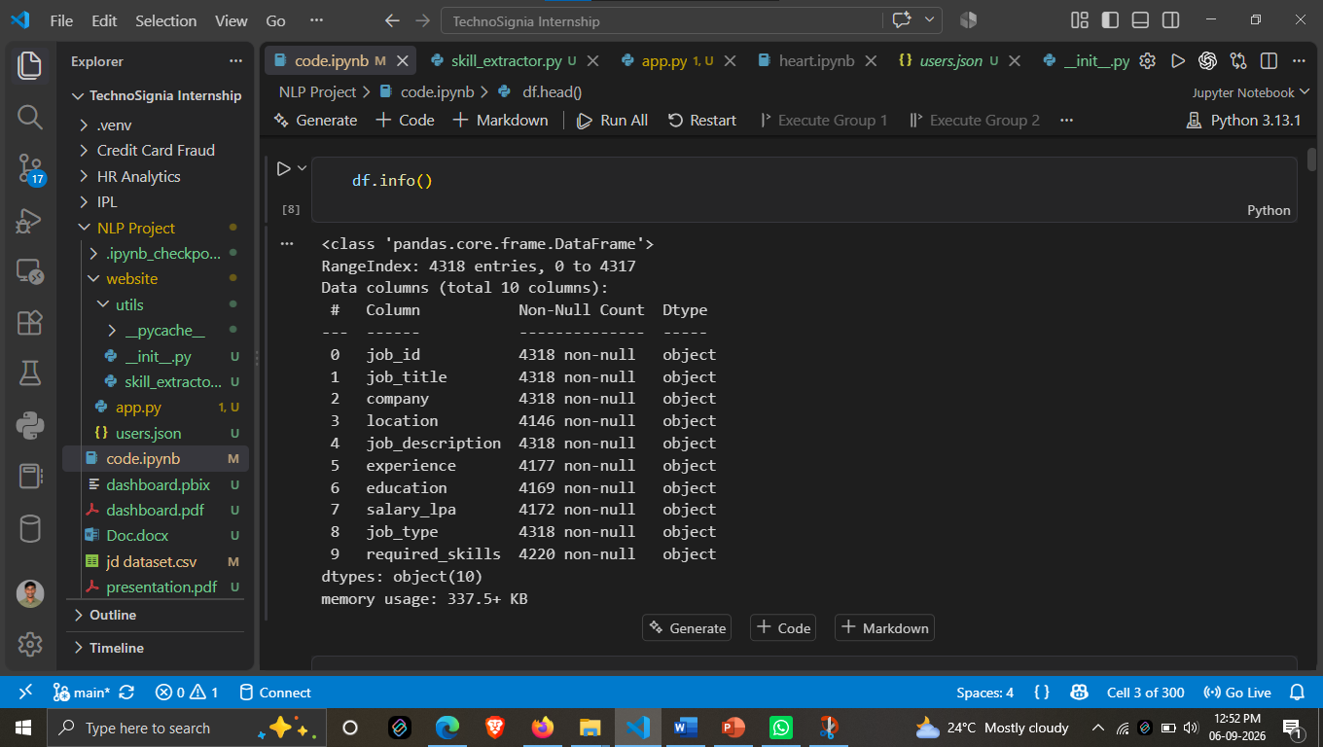
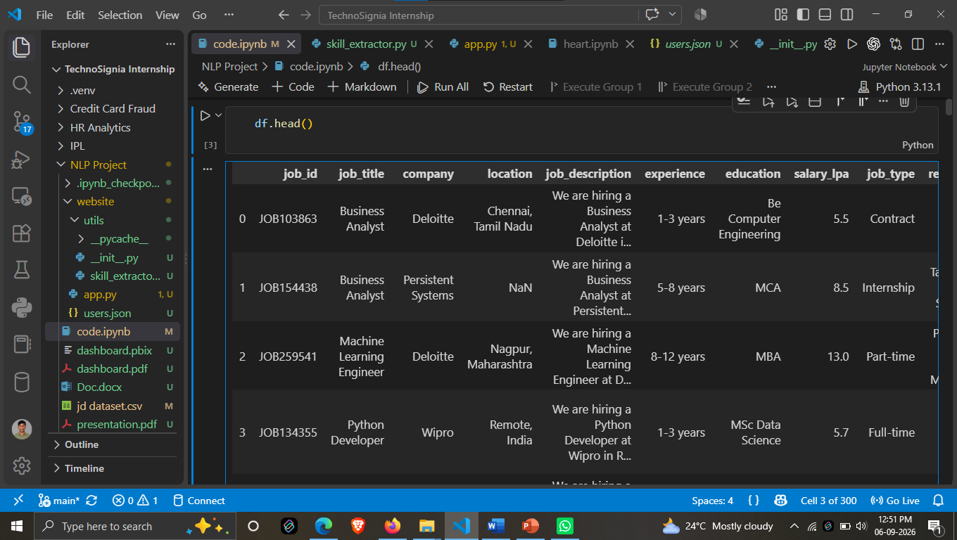
6.4 Data Inspection
Before model development, the dataset was inspected to understand its structure, quality, and contents. The inspection included:
- Checking the number of records and columns.
- Identifying missing or empty values.
- Examining job-description text.
- Checking duplicate records.
- Understanding the distribution of available data.
- Verifying the skill annotations used for NER training.

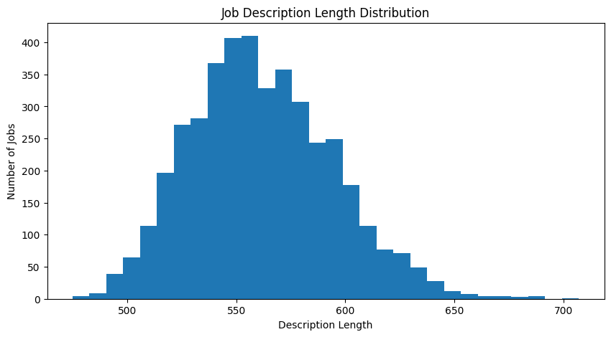

Basic data analysis and visualization were performed using Pandas, NumPy, Matplotlib, and Seaborn.
6.5 Dataset Preparation
After inspection, the relevant data was cleaned and prepared for the NLP pipeline. The job-description text and corresponding skill annotations were converted into a suitable format for training the DistilBERT-based NER model.
The prepared dataset was then used for model training, validation, and performance evaluation.

7. EXPLORATORY DATA ANALYSIS (EDA)
7.1 Overview
Exploratory Data Analysis was performed to understand the structure, distribution, and characteristics of the job-description dataset before applying NLP techniques. The analysis included job titles, companies, locations, education requirements, description length, and other important attributes.
7.2 Dataset Overview
The dataset contains 4,200 job records and 123 unique job titles. The analysis also identified 165 unique companies and 88 unique job locations.
7.3 Job Title Analysis
The dataset contains a variety of job roles. The most frequently occurring job titles include Software Engineer, Cloud Engineer, Data Scientist, Machine Learning Engineer, Web Developer, AI Engineer, SQL Developer, Data Engineer, Data Analyst, and Business Analyst.
The analysis shows that software, data, cloud, and AI-related roles form a significant portion of the dataset.
Figure 7.1: Top 10 Job Titles
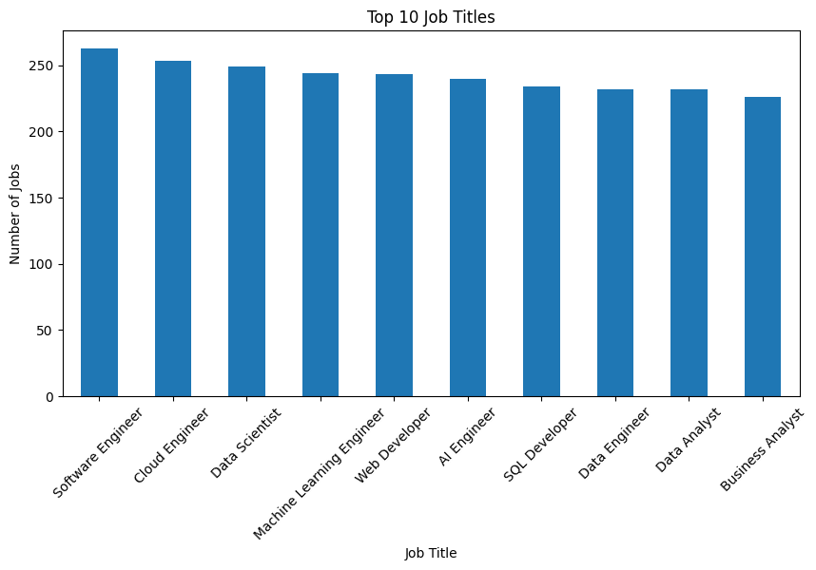7.4 Location Analysis
The dataset contains 88 unique locations. The analysis shows job opportunities distributed across different Indian locations, including Hyderabad, Remote, Ahmedabad, Nashik, Noida, Delhi, Chennai, Nagpur, Mumbai, and Gurugram.
Figure 7.2: Top 10 Job Locations
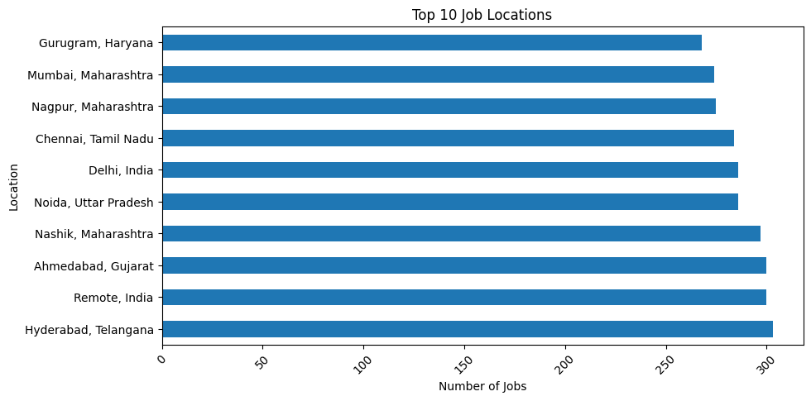7.5 Company Analysis
A total of 165 unique companies are present in the dataset. Companies such as Siemens, Cognizant, Oracle, Fractal Analytics, Zoho, Cognida, Capgemini, Tech Mahindra, Infosys, and IBM appear among the frequently represented companies.
Figure 7.3: Top 10 Companies
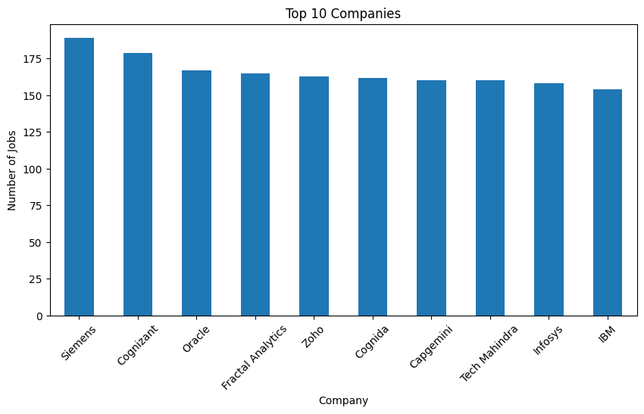7.6 Education Requirement Analysis
The dataset contains different educational requirements for job roles. The frequently observed requirements include B.Tech Computer Science, B.Sc Data Science, Any Graduate, BCA, and MBA.
Figure 7.4: Top 5 Education Requirements
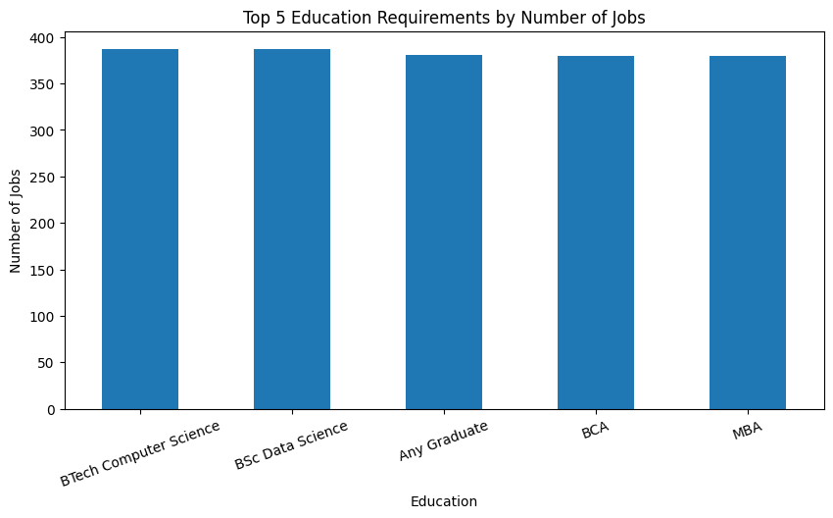7.7 Job Description Length Analysis
The average job-description length is approximately 561.67, while the minimum and maximum description lengths are 475 and 707, respectively.
This analysis helps understand the textual size and consistency of job descriptions before applying NLP processing.
Figure 7.5: Job Description Length Analysis
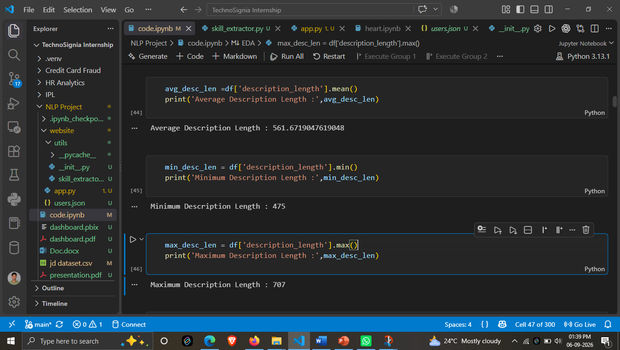7.8 Key EDA Findings
The major findings from the exploratory analysis are:
- Total job records: 4,200
- Unique job titles: 123
- Unique companies: 165
- Unique locations: 88
- Average description length: 561.67
- Minimum description length: 475
- Maximum description length: 707
- Average salary: 8.87 LPA
The EDA provided an understanding of the dataset and helped prepare the data for subsequent NLP preprocessing and skill extraction.
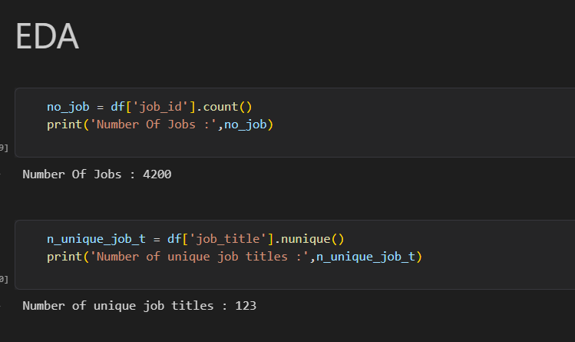

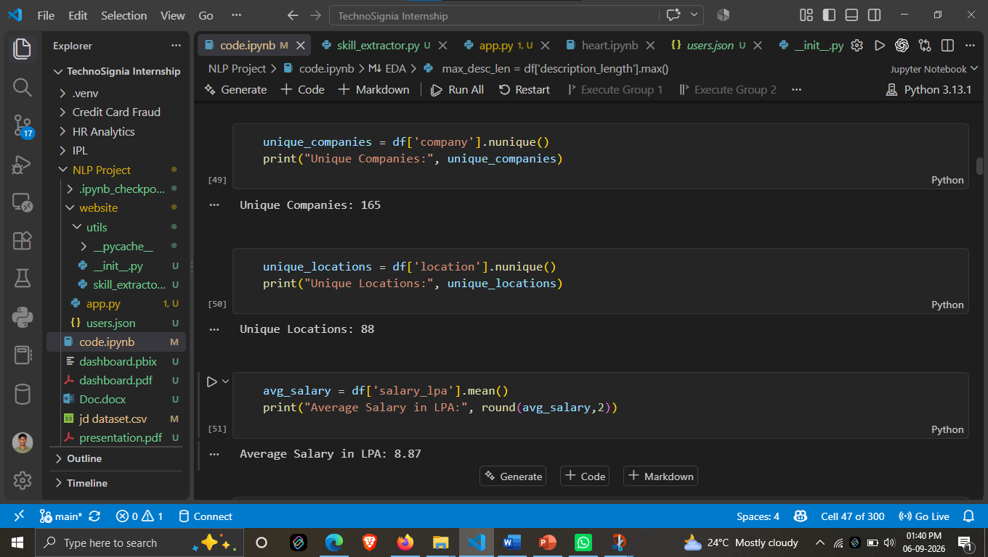

8. DATA CLEANING & NLP PREPROCESSING
8.1 Data Cleaning
Data cleaning was performed to improve the quality and consistency of the job-description dataset before applying NLP techniques. Unnecessary or inconsistent text elements were handled during preprocessing.
The main cleaning activities included:
- Handling missing or empty values.
- Removing unnecessary characters and unwanted text.
- Removing duplicate records where applicable.
- Standardizing textual data.
- Preparing job descriptions for further NLP processing.
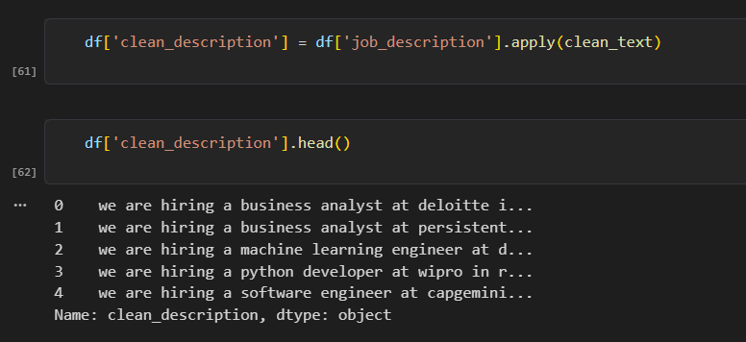
8.2 Tokenization
Tokenization is the process of dividing text into smaller units called tokens. These tokens can represent individual words or sub-word units.
For example:
Input:
Experience in Python and Machine Learning
Tokens:
Experience | in | Python | and | Machine | Learning
For the transformer-based model, the final tokenization is performed using the DistilBERT tokenizer.
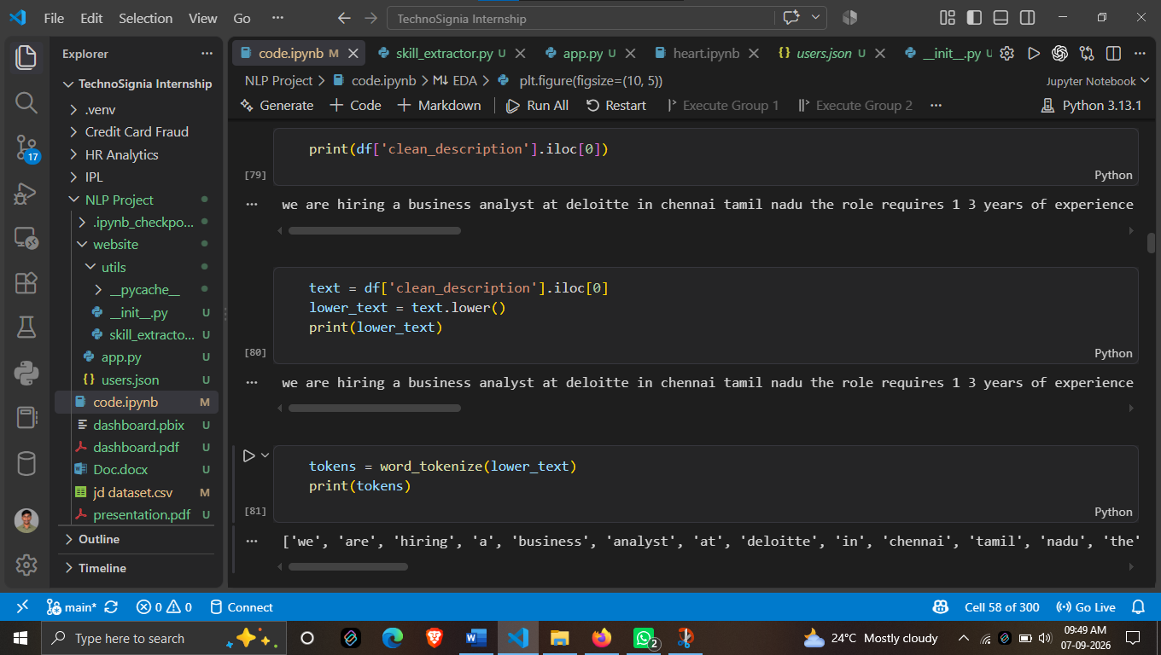
8.3 Stopword Removal
Stopwords are commonly occurring words such as the, is, in, and, of, etc., which may provide limited information for some NLP tasks.
Stopword handling can reduce unnecessary textual information during traditional NLP preprocessing. However, for the DistilBERT-based NER model, excessive removal of words is avoided because contextual information can be important for identifying entities.
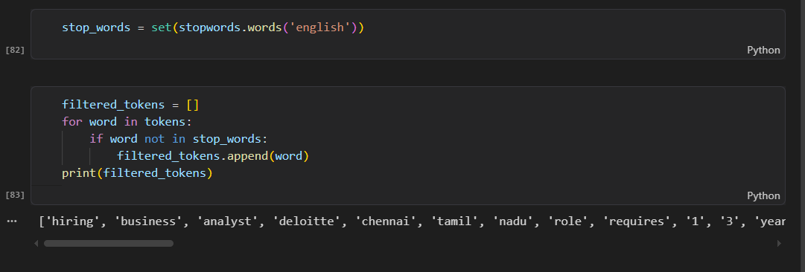
8.4 Stemming
Stemming reduces words to their basic stem by removing prefixes or suffixes.
For example:
learning → learn
Stemming is useful in traditional NLP workflows for reducing variations of words. However, it should be applied carefully in skill extraction because changing a technical term may affect its meaning.
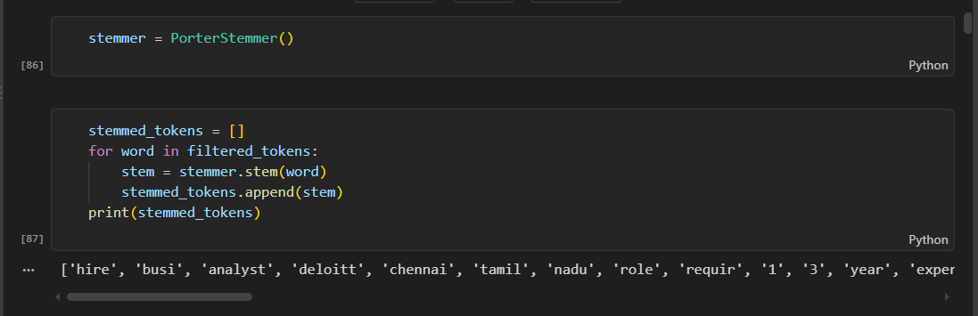
8.5 Lemmatization
Lemmatization converts words into their meaningful base or dictionary form.
For example:
running → run
Lemmatization can help normalize different forms of words while preserving their linguistic meaning. It is mainly useful during text analysis and preprocessing.
8.6 Sentence Segmentation
Sentence segmentation divides a job description into individual sentences. This helps organize the text and supports sentence-level NLP analysis.
For example:
Job Description:
We need a Python developer. Experience with SQL is required.
Segments:
- We need a Python developer.
- Experience with SQL is required.
8.7 Preprocessing Workflow
The overall preprocessing workflow can be summarized as:
Raw Job Description → Data Cleaning → Text Normalization → Tokenization → NLP Processing → DistilBERT NER Model
The preprocessing stage prepares the job-description text for effective skill extraction while preserving the contextual information required by the transformer-based NER model.
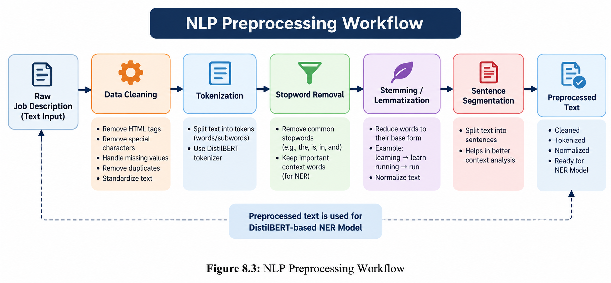

- SKILL TAXONOMY DEVELOPMENT

9.1 Skill Dictionary
A skill dictionary is a structured collection of skills used to identify relevant technical and professional skills from job descriptions. It provides a reference list against which extracted skill entities can be analyzed and standardized.
The SkillSense skill dictionary may contain programming languages, frameworks, databases, cloud technologies, data science tools, development tools, and other job-related competencies.
Examples include:
- Python
- Java
- SQL
- Machine Learning
- TensorFlow
- React
- AWS
- Docker
9.2 Skill Categories
To organize the extracted skills effectively, skills can be grouped into different categories.
Category | Examples
Programming Languages | Python, Java, C++, JavaScript
Data & Database | SQL, MySQL, PostgreSQL, MongoDB
Machine Learning & AI | Machine Learning, Deep Learning, NLP
Frameworks & Libraries | React, Django, TensorFlow, PyTorch
Cloud & DevOps | AWS, Azure, Docker, Kubernetes
Data Visualization | Power BI, Tableau, Matplotlib
Tools & Technologies | Git, GitHub, Jupyter, VS Code
9.3 Aliases and Synonyms
The same skill can appear in different forms in job descriptions. Aliases and synonyms help map these different expressions to the same underlying skill.
Examples:
Mentioned Term | Canonical Skill
Python3, Python 3.x | Python
PostgreSQL, Postgres | PostgreSQL
ML | Machine Learning
NLP, Natural Language Processing | Natural Language Processing
PowerBI, Power BI | Power BI
This normalization helps avoid treating different representations of the same skill as separate skills.
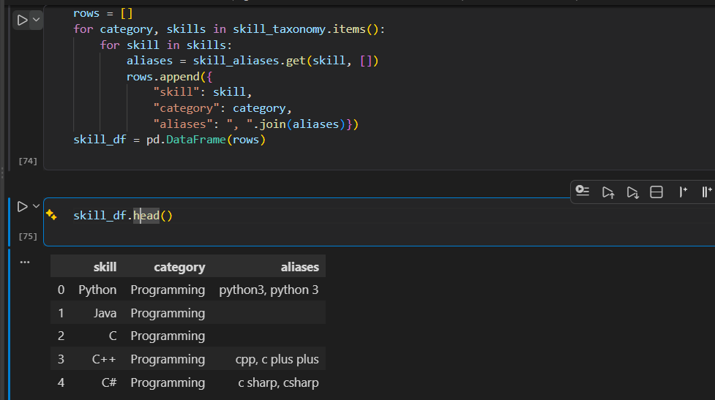
9.4 Canonical Skills
A canonical skill is the standardized name assigned to a skill after processing its different aliases or variations.
For example:
Python3, Python 3.x, Python → Python
ML, Machine Learning → Machine Learning
Canonicalization makes the final extracted skill list more consistent and useful for further analysis.
9.5 Role in SkillSense
The skill taxonomy supports the SkillSense system by:
- Organizing extracted skills into meaningful categories.
- Handling different names and variations of the same skill.
- Reducing duplicate skill representations.
- Standardizing extracted results.
- Improving the consistency of skill-based analysis.
The overall taxonomy process can be represented as:
Raw Skill Mention → Alias/Synonym Detection → Canonical Mapping → Skill Category → Standardized Skill

10. RULE-BASED SKILL EXTRACTION

Rule-Based Skill Extraction is used as an initial approach for identifying skills from job descriptions. It relies on predefined skill dictionaries, regular expressions, and phrase-matching techniques to detect known skill terms in the input text.
10.1 Dictionary Matching
A predefined skill dictionary is used to match known skills with terms present in the job description. When a skill from the dictionary is found in the input text, it is added to the extracted skill list.
This approach is simple, fast, and effective for identifying commonly known skills.
Example:
Python, SQL, Java, Machine Learning
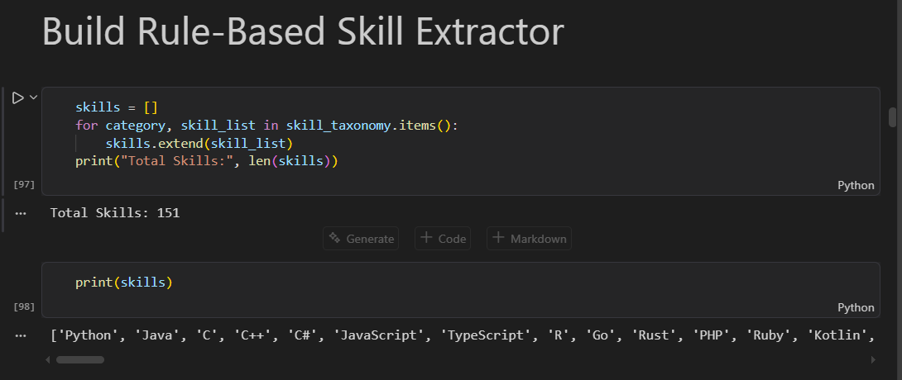
10.2 Regex-Based Matching
Regular Expressions (Regex) are used to identify specific patterns or variations of skill names in the job description. Regex matching is useful when a skill can appear in different formats.
For example, patterns can be designed to identify variations such as:
- Python 3
- Python3
- C++
- C#
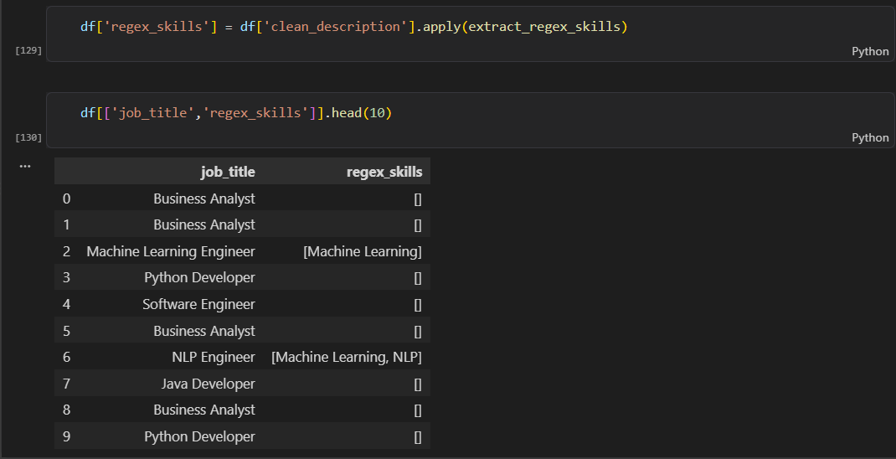
Regex-based matching improves the ability to detect skills with different textual representations.
10.3 Phrase Matching
Phrase matching is used to identify multi-word skills or technical terms that consist of more than one word.
Examples include:
- Machine Learning
- Deep Learning
- Natural Language Processing
- Data Science
- Computer Vision
The complete phrase is matched instead of treating each word separately, which helps maintain the correct meaning of the skill.
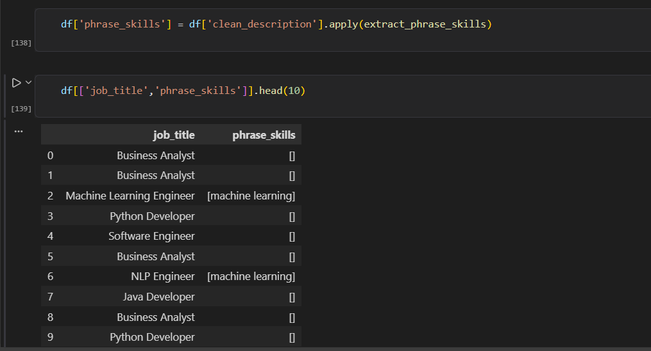
10.4 Rule-Based Extraction Workflow
The rule-based extraction process can be summarized as:
Job Description → Dictionary Matching → Regex Matching → Phrase Matching → Extracted Skills
Rule-based extraction provides a baseline approach for skill identification and can also complement the transformer-based DistilBERT NER model used in SkillSense.

11. STATISTICAL & SEMANTIC NLP TECHNIQUES

Statistical and semantic NLP techniques are useful for representing and analyzing textual information. In the SkillSense project, these techniques provide different approaches for understanding job-description text and identifying relationships between skills and job requirements.
11.1 TF-IDF
Term Frequency–Inverse Document Frequency (TF-IDF) is a statistical technique used to measure the importance of words within a document relative to a collection of documents.
TF-IDF gives higher importance to terms that occur frequently in a particular document but are less common across the complete dataset. It can be useful for identifying important terms in job descriptions.
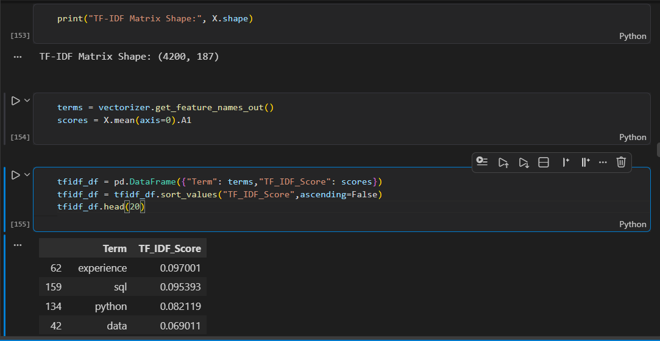
11.2 N-Grams
N-Grams are sequences of consecutive words or tokens extracted from text.
Examples:
- Unigram: Machine
- Bigram: Machine Learning
- Trigram: Natural Language Processing
N-Grams help capture meaningful multi-word expressions that may represent skills or technical concepts.
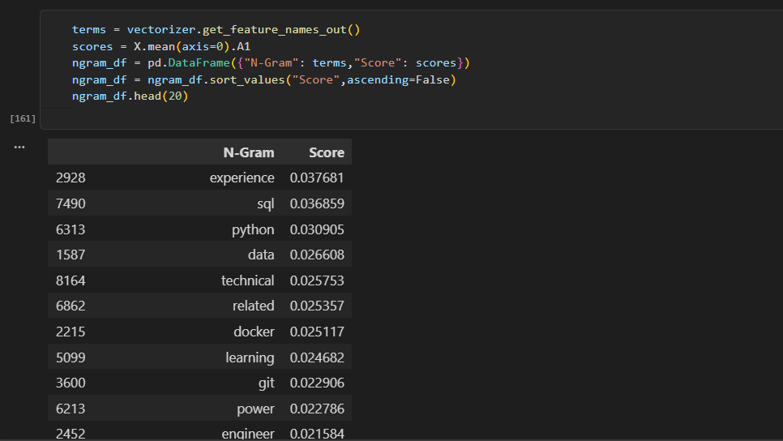

11.3 Word Embeddings
Word Embeddings represent words or tokens as numerical vectors in a continuous vector space. Words with similar meanings or contextual usage can have similar vector representations.
Embeddings are useful for capturing semantic relationships between terms and are an important concept in modern NLP and transformer-based models.
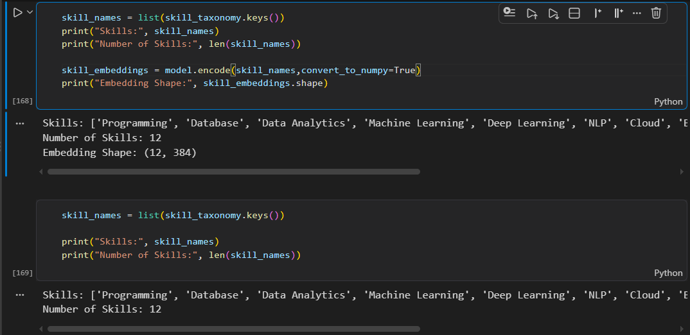
11.4 Semantic Similarity
Semantic Similarity measures how closely two words, phrases, or documents are related in meaning.
For example, terms such as:
Machine Learning ↔ ML
may be considered semantically related even though their textual forms are different.
Semantic similarity can therefore support skill matching, synonym identification, and comparison of job requirements.
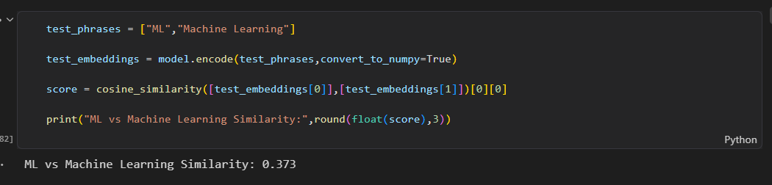
11.5 Role in SkillSense
These techniques provide different levels of text understanding:
TF-IDF → Term Importance
N-Grams → Phrase Information
Word Embeddings → Semantic Representation
Semantic Similarity → Meaning-Based Comparison
Together, statistical and semantic techniques provide a foundation for analyzing job-description text and understanding relationships between skills.

12. NAMED ENTITY RECOGNITION (NER)

12.1 Standard NER
Named Entity Recognition (NER) is an NLP technique used to identify and classify important entities present in text. Standard NER models commonly identify entities such as Person, Organization, Location, Date, and other general entities.
For example:
Input:
Google is hiring a Python Developer in Mumbai.
Possible entities:
- Google → Organization
- Python → Skill/Technology
- Mumbai → Location
Standard NER is useful for general-purpose entity identification but may not specifically recognize all technical skills required from job descriptions.
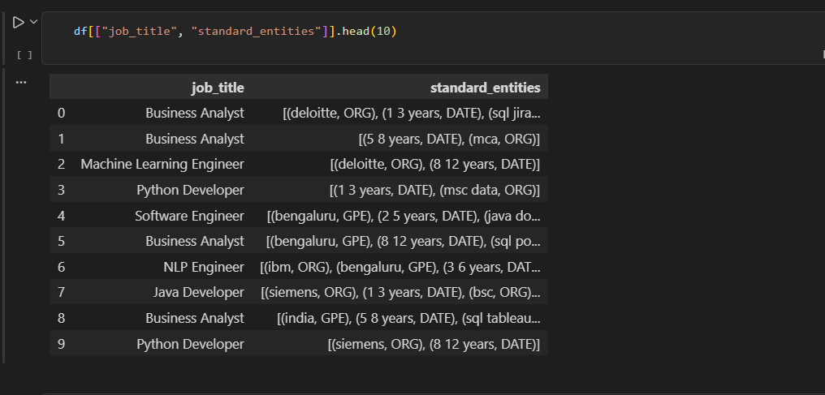
12.2 Custom Entities
For the SkillSense project, the focus is on identifying job-related skill entities. Therefore, a custom entity category is used to identify skills such as:
- Python
- SQL
- Machine Learning
- TensorFlow
- Power BI
- Java
- AWS
The custom entity approach allows the model to focus specifically on skill-related information rather than only general-purpose entities.
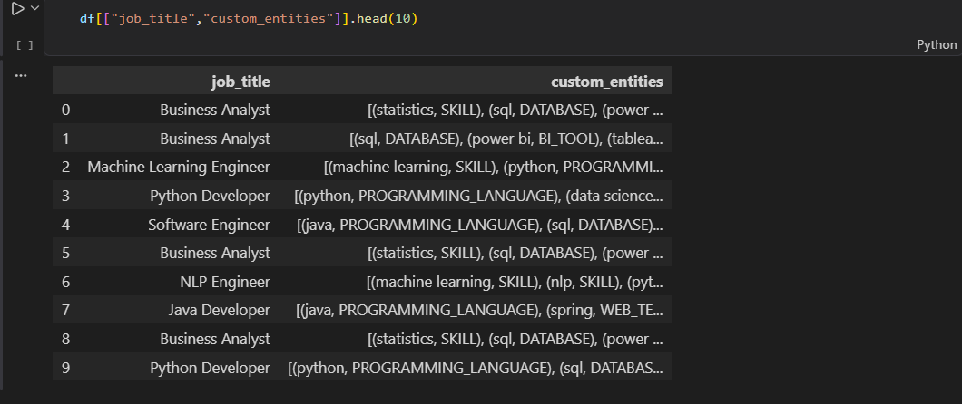
12.3 Custom NER Approach
SkillSense uses a custom NER approach based on a fine-tuned DistilBERT model. The model is trained on job-description data containing skill-related annotations.
The workflow is:
Annotated Job Dataset → Tokenization → DistilBERT Fine-Tuning → Custom NER Model → Skill Entity Prediction
During prediction, the model analyzes the context of the job description and identifies text spans representing relevant skills.
For example:
Input:
The candidate should have experience in Python, SQL and Machine Learning.
Extracted Skills:
Python | SQL | Machine Learning
The custom NER approach enables SkillSense to perform domain-specific skill extraction from unstructured job descriptions.

13. MACHINE LEARNING MODEL TRAINING

13.1 Training Data
The prepared job-description dataset was used for training and evaluating the machine learning model. The dataset was divided into suitable training and testing sets to evaluate the model on unseen data.
The training data contains job-related textual information and the corresponding target information required for the selected machine learning task.
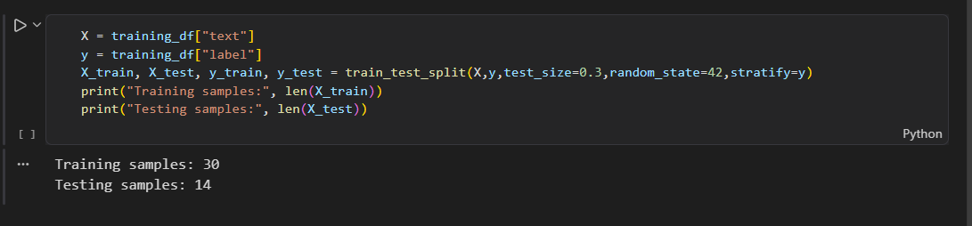
13.2 Feature Engineering
Since machine learning models cannot directly process raw text, the textual job descriptions were converted into numerical features.
TF-IDF (Term Frequency–Inverse Document Frequency) was used to transform the job-description text into numerical feature vectors. In the project, the generated TF-IDF matrix contains 4,200 documents and 187 features.
This representation allows the machine learning model to identify patterns and relationships within the textual data.
13.3 TF-IDF + Machine Learning Model
The machine learning pipeline combines TF-IDF vectorization with a machine learning model.
The workflow is:
Job Description → Text Preprocessing → TF-IDF Vectorization → ML Model → Prediction
TF-IDF converts the text into numerical vectors, which are then provided as input to the machine learning model for training and prediction.
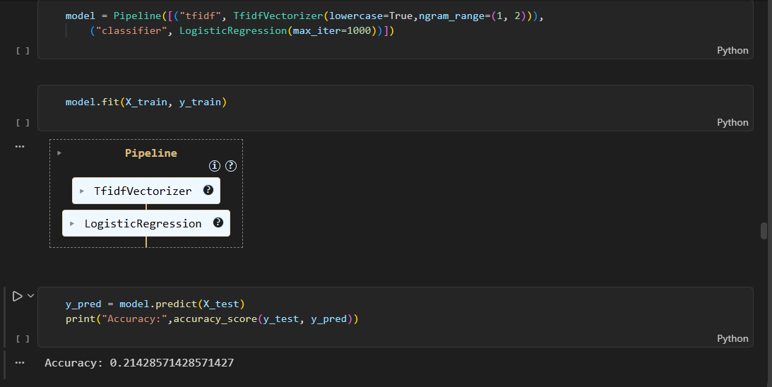

13.4 Classification Pipeline
The classification pipeline consists of the following stages:
Job Description
↓
Text Preprocessing
↓
TF-IDF Vectorization
↓
Training / Testing Split
↓
Machine Learning Model
↓
Prediction
↓
Performance Evaluation
The trained model is evaluated using appropriate performance metrics such as Accuracy, Precision, Recall, and F1-Score, depending on the classification task.
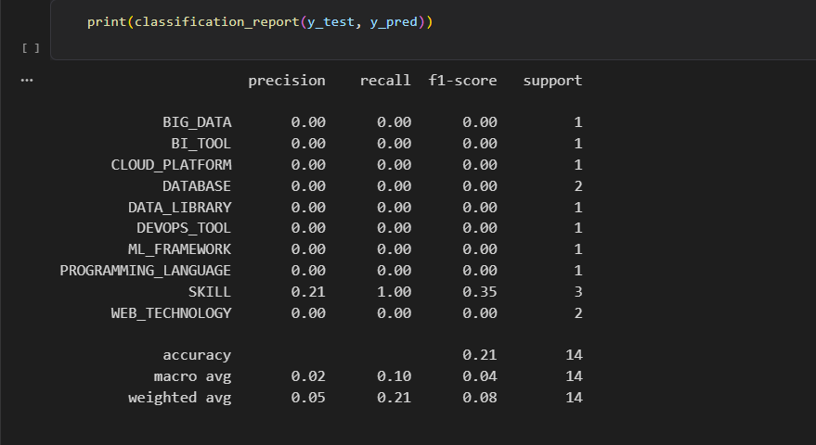
13.5 Model Training Process
The overall training process includes:
- Preparing the cleaned dataset.
- Splitting the data into training and testing sets.
- Applying TF-IDF vectorization.
- Training the selected machine learning model.
- Generating predictions on test data.
- Evaluating model performance.
- Comparing the obtained results.

14. Transformer-Based Model
14.1 Transformer Model Overview
Transformer-based models are modern NLP models designed to understand the contextual relationships between words in a text. Popular transformer models include BERT, DistilBERT, and RoBERTa.
For the SkillSense project, DistilBERT was selected for skill extraction because it provides contextual language understanding while being lighter and faster than the original BERT model.
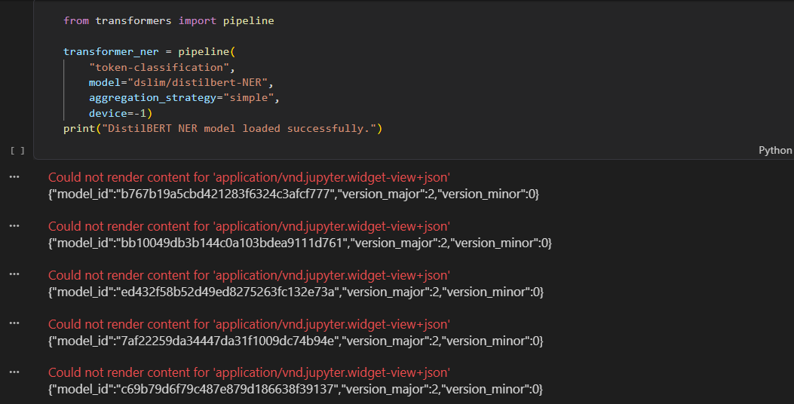
14.2 DistilBERT Model Approach
SkillSense uses a fine-tuned DistilBERT model for Named Entity Recognition (NER). The pretrained DistilBERT model is adapted to the specific task of identifying skill-related entities from job descriptions.
The model learns from annotated job-description data where relevant skills are marked as target entities.
The approach is:
Pretrained DistilBERT → Fine-Tuning with Skill Dataset → Custom NER Model → Skill Prediction
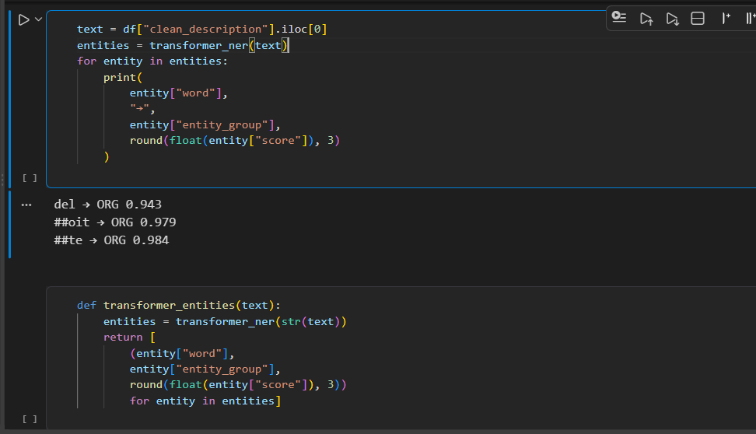

14.3 Skill Extraction Process
When a new job description is provided, the extraction process follows these steps:
- Input: User provides a job description.
- Tokenization: The text is converted into model-compatible tokens.
- Contextual Processing: DistilBERT analyzes the relationship between tokens and their surrounding context.
- Entity Prediction: The NER layer predicts whether tokens belong to a skill entity.
- Entity Grouping: Related tokens are combined to form complete skill phrases.
- Post-Processing: Duplicate or unnecessary results are cleaned.
- Output: The final extracted skills are displayed to the user.
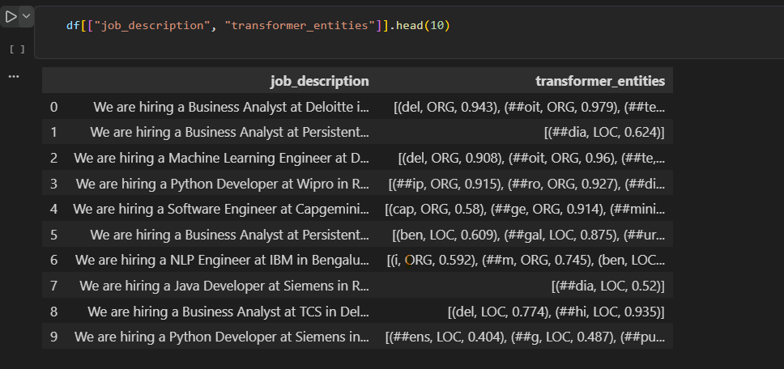
Example
Input:
Experience in Python, SQL and Machine Learning is required.
Extracted Skills:
Python | SQL | Machine Learning
14.4 Overall Extraction Pipeline
Job Description
↓
DistilBERT Tokenizer
↓
Fine-Tuned DistilBERT NER
↓
Entity Prediction
↓
Skill Entity Grouping
↓
Post-Processing
↓
Extracted Skills
The transformer-based approach enables SkillSense to identify skills based on context, making it more suitable for job-description analysis than simple keyword matching alone.

15. MODEL EVALUATION & COMPARISON

The developed models were evaluated using standard performance metrics to measure their effectiveness in identifying and classifying relevant information from job-description data. The main evaluation metrics used are Precision, Recall, F1-Score, and Accuracy. A Confusion Matrix was also used to analyze classification performance.
15.1 Precision
Precision measures how many of the entities predicted by the model are actually correct.
Precision=TPTP+FPPrecision = \frac{TP}{TP + FP}
A higher precision indicates fewer false-positive predictions.
15.2 Recall
Recall measures how many of the actual relevant entities were correctly identified by the model.
Recall=TPTP+FNRecall = \frac{TP}{TP + FN}
A higher recall indicates that the model is able to identify more relevant skills.
15.3 F1-Score
F1-Score is the harmonic mean of Precision and Recall.
F1=2×Precision×RecallPrecision+RecallF1 = 2 \times \frac{Precision \times Recall}{Precision + Recall}
It provides a balanced measure when both precision and recall are important.
15.4 Accuracy
Accuracy represents the proportion of correct predictions among all predictions.
Accuracy=TP+TNTP+TN+FP+FNAccuracy = \frac{TP + TN}{TP + TN + FP + FN}
Accuracy is mainly useful for evaluating classification models where the class distribution is reasonably balanced.
15.5 Confusion Matrix
A Confusion Matrix provides a detailed view of classification results by showing correct and incorrect predictions for different classes.
It consists of:
- True Positive (TP)
- True Negative (TN)
- False Positive (FP)
- False Negative (FN)
The confusion matrix helps identify which classes are being predicted correctly and where classification errors occur.
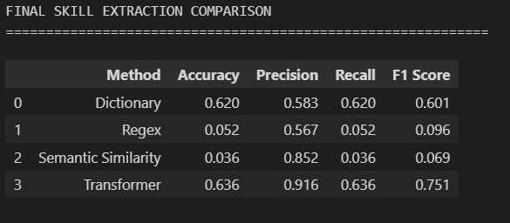

15.6 Model Comparison
Different approaches used in the project were compared based on their evaluation performance. The comparison helps determine which approach provides better results for the given task.
A typical comparison table can be presented as:
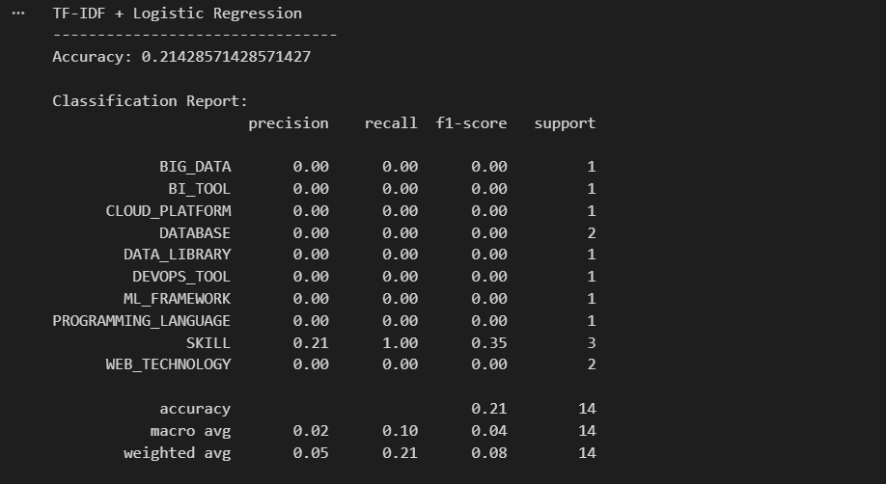
15.7 Evaluation Summary
The evaluation results provide a quantitative comparison of the implemented approaches. Precision, Recall, and F1-Score are particularly important for skill extraction because the system needs to identify relevant skills while minimizing incorrect predictions.

16. ERROR ANALYSIS
Error analysis was performed to understand the limitations and incorrect predictions produced during skill extraction. It helps identify areas where the NLP models and extraction rules can be improved.
16.1 False Positives
A false positive occurs when the system identifies a word or phrase as a skill even though it is not a relevant skill.
Example:
A common word or organization name may incorrectly be identified as a skill entity.
16.2 False Negatives
A false negative occurs when an actual skill mentioned in the job description is not detected by the system.
Example:
A less common technology or newly introduced skill may be missed if it is not sufficiently represented in the training data or skill dictionary.
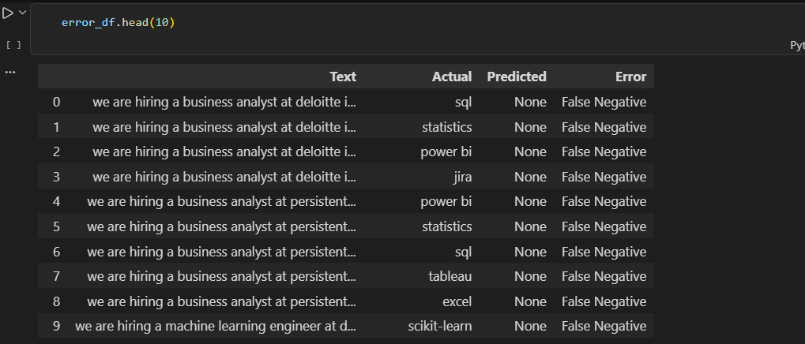
16.3 Partial Entities
Sometimes the system identifies only part of a multi-word skill instead of the complete entity.
Example:
Machine Learning → Machine
instead of:
Machine Learning
This can occur because of token-level prediction or incorrect entity grouping.
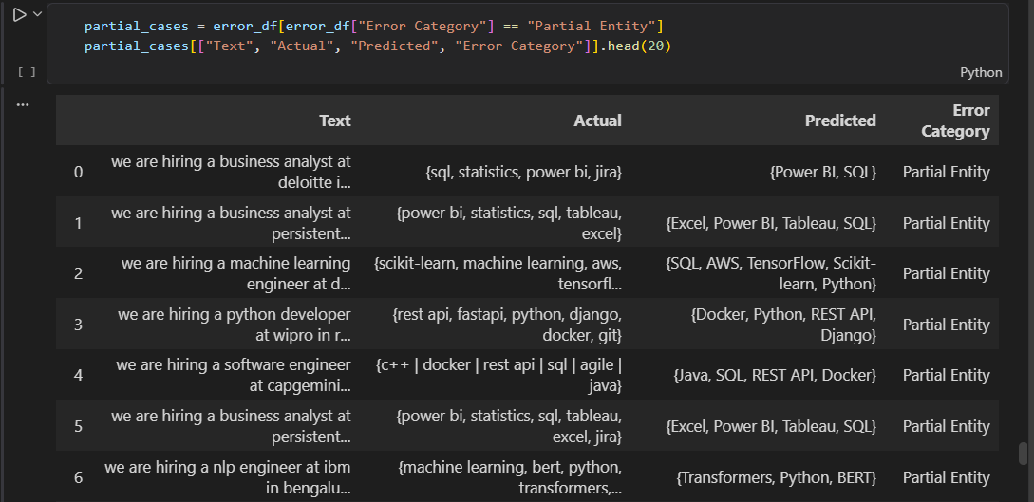
16.4 Synonyms and Skill Variations
The same skill can appear in different forms in job descriptions.
Examples:
- ML → Machine Learning
- NLP → Natural Language Processing
- Postgres → PostgreSQL
If these variations are not properly mapped, the system may treat them as different skills or fail to recognize them.
16.5 Spelling Issues
Spelling mistakes, abbreviations, and inconsistent formatting can affect skill extraction.
Examples:
- Pythn instead of Python
- PowerBI instead of Power BI
- Tensor flow instead of TensorFlow
Such variations may result in missed or incorrectly extracted skills.
16.6 Error Analysis Summary
The major sources of errors are:
Error Type | Effect
False Positive | Incorrect skill identification
False Negative | Actual skill is missed
Partial Entity | Incomplete skill extraction
Synonyms | Same skill treated differently
Spelling Issues | Skill may not be recognized
Error analysis indicates that better training data, improved entity grouping, skill normalization, synonym handling, and spelling correction can improve the overall quality of skill extraction.

17. SKILL NORMALIZATION & CATEGORIZATION
Skill normalization is the process of converting different representations of the same skill into a common standardized form. This helps SkillSense produce consistent and non-duplicated skill results.
17.1 Alias Matching
The system handles different names, abbreviations, and variations of skills by mapping them to a common skill.
Examples:
Alias / Variation | Canonical Skill
ML | Machine Learning
NLP | Natural Language Processing
Python 3 | Python
Postgres | PostgreSQL
PowerBI | Power BI
This prevents the same skill from being treated as multiple different skills.
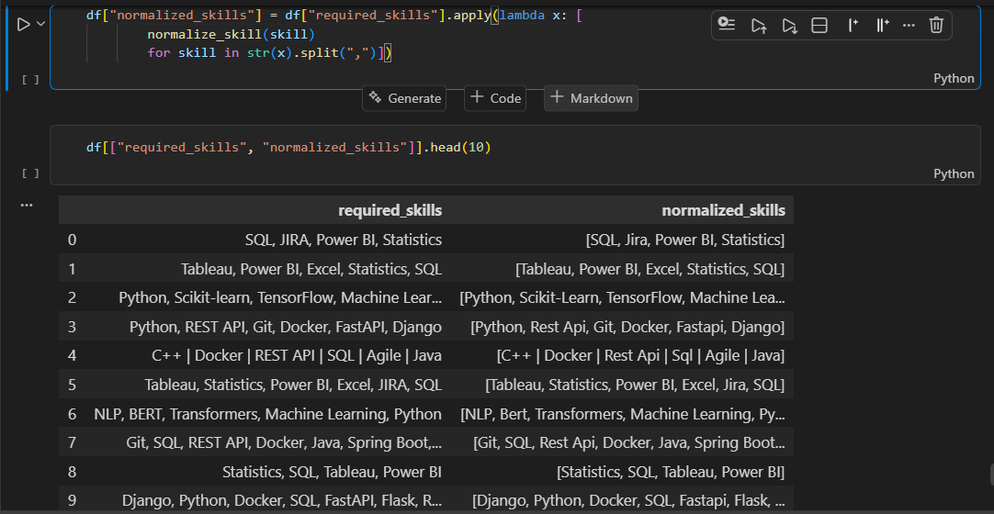
17.2 Canonical Skills
A canonical skill is the standardized name assigned to a skill after processing its aliases and variations.
For example:
ML → Machine Learning
Python3 → Python
PowerBI → Power BI
Canonicalization makes the extracted output cleaner and more consistent.
17.3 Category Mapping
After normalization, skills can be mapped to appropriate categories based on their technical domain.
Skill | Category
Python | Programming Language
SQL | Database
TensorFlow | Machine Learning / AI
React | Framework
AWS | Cloud
Power BI | Data Visualization
This categorization makes the extracted skills easier to analyze and visualize.
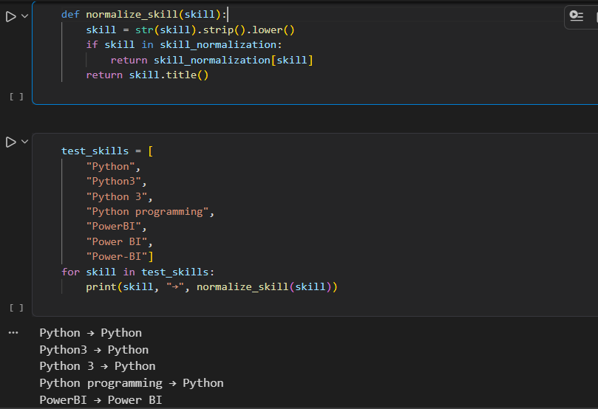
17.4 Normalization Workflow
The complete process can be represented as:
Extracted Skill
↓
Alias / Variation Matching
↓
Canonical Skill
↓
Category Mapping
↓
Normalized Skill Output
Skill normalization and categorization improve the consistency of extracted results and make them more useful for skill analysis, comparison, and recruitment-related applications.

18. DASHBOARD & DATA VISUALIZATION

18.1 Dashboard Overview
A Power BI dashboard was developed to present the job-market and skill-related analysis in an interactive and easy-to-understand format. The dashboard combines key performance indicators, skill demand, job-role analysis, skill categories, and salary information.
18.2 Key Performance Indicators (KPIs)
The dashboard provides important summary indicators:
- Total Jobs: 4,292
- Unique Skills: 58
- Top Skill: SQL
- Top Job Role: Software Engineer
- Most Required Technology: SQL
- Top Skill Category: Machine Learning
18.3 Top Skills
The Top 20 Most Demanded Skills visualization shows the most frequently required skills in the dataset. SQL and Python are among the most demanded skills, followed by technologies such as Docker, Git, Machine Learning, AWS, REST API, TensorFlow, and Power BI.
18.4 Skill Demand by Job Role
The dashboard provides a comparison of skill demand across different job roles, including Software Engineer, Cloud Engineer, AI Engineer, Data Scientist, and Web Developer. This helps understand which technologies are associated with different job positions.
18.5 Skill Category Distribution
The dashboard represents the distribution of skills across categories such as Machine Learning, DevOps, Programming, Database, Analytics, Backend, Other, and Cloud. This provides an overview of the major skill domains represented in the dataset.
18.6 Salary Analysis
The dashboard also includes Average Salary by Job Role, allowing comparison of average salary values across roles such as Web Developer, Data Scientist, Software Engineer, Machine Learning Engineer, DevOps Engineer, Power BI Developer, Python Developer, Java Developer, SQL Developer, and NLP Engineer.
18.7 Dashboard Filters
Interactive filters are provided for Education and Job Title, allowing users to analyze the dashboard based on selected educational qualifications and job roles.
18.8 Visualization Summary
The Power BI dashboard converts the processed job and skill data into interactive visual insights. It helps users understand skill demand, job-role requirements, skill categories, and salary patterns in a single interface.
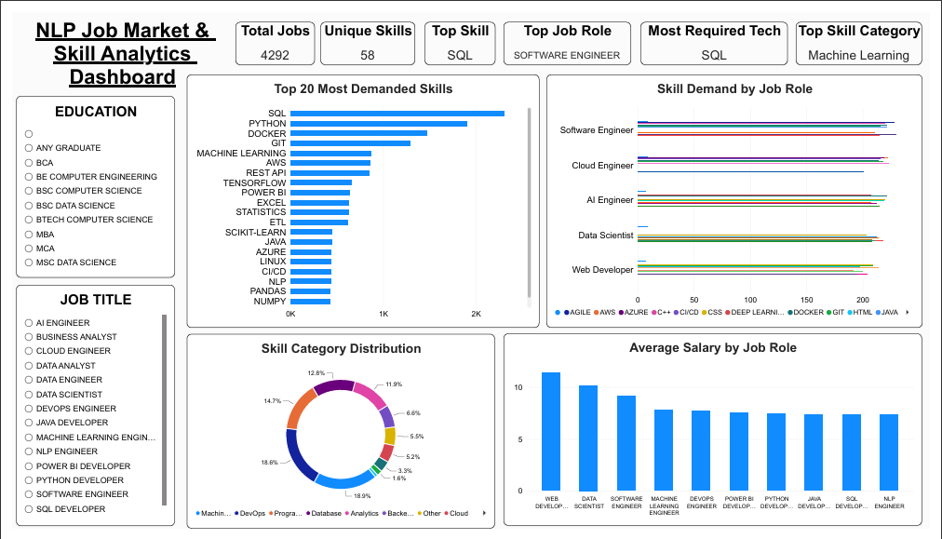

19. APPLICATION / API DEVELOPMENT
19.1 Application Interface
The SkillSense application provides a user-friendly web interface developed using Streamlit. The interface allows users to enter a job description and submit it for automated skill analysis.
The application connects the user interface with the trained NLP model and displays the extracted skills in a structured format.
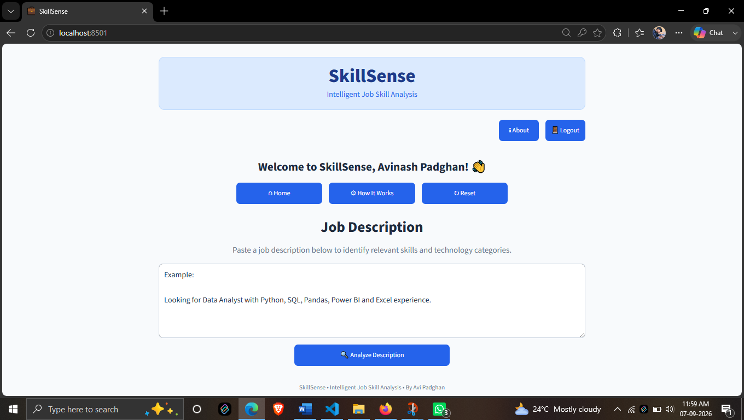
19.2 Input and Output
Input
The primary input to the application is an unstructured job description containing information about job requirements, technologies, qualifications, and skills.
Output The system processes the input job description and provides the identified skills as the output .Input → Job Description Output → Extracted Skills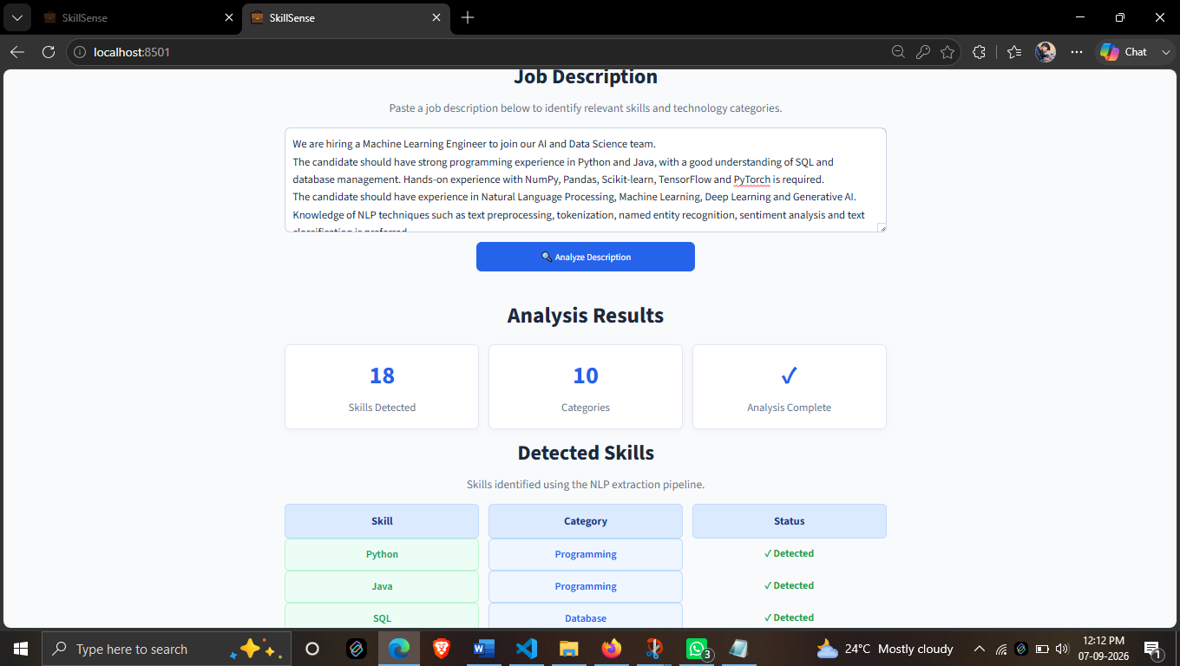

19.3 Skill Extraction Pipeline
The application follows the following extraction pipeline:
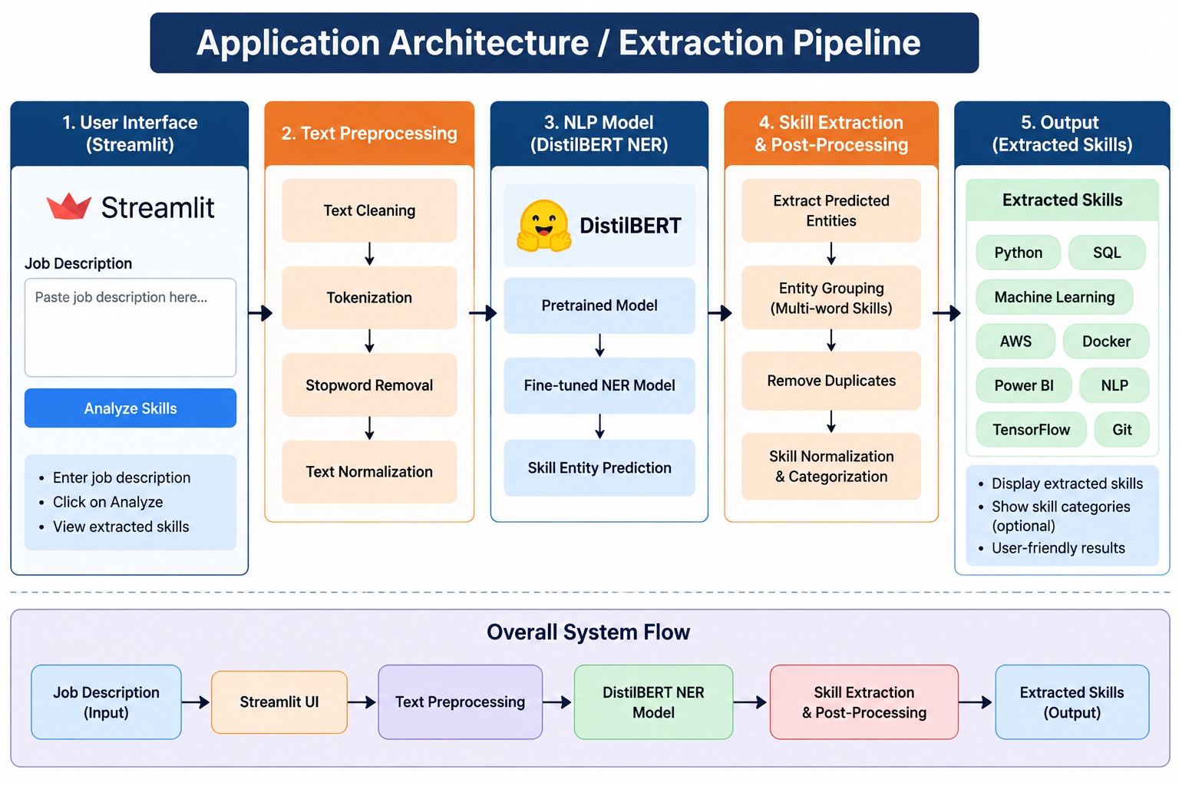
This pipeline connects the frontend interface with the NLP processing and skill extraction components.
19.4 Application Architecture
The application can be divided into three major components:
1. User Interface
Streamlit provides the interface for entering job descriptions and viewing results.
2. NLP Processing Layer
The input text is processed and passed to the fine-tuned DistilBERT-based NER model.
3. Output Layer
The predicted skill entities are processed and displayed as the final skill list.
┌──────────────────────┐
│ Streamlit UI │
│ Job Description │
└──────────┬───────────┘
↓
┌──────────────────────┐
│ NLP Processing │
│ + DistilBERT NER │
└──────────┬───────────┘
↓
┌──────────────────────┐
│ Skill Extraction & │
│ Post-Processing │
└──────────┬───────────┘
↓
┌──────────────────────┐
│ Extracted Skills │
│ Output │
└──────────────────────┘
19.5 Application Result
The developed application provides an interactive way to analyze job descriptions without requiring the user to directly interact with the underlying Python or NLP code. It demonstrates the integration of the trained skill extraction model into a practical web-based application.

20. TESTING & RESULTS
20.1 Testing
The SkillSense application was tested using different job-description inputs to verify the functionality of the NLP-based skill extraction pipeline. Testing was performed to ensure that the application accepts input correctly, processes the text, extracts relevant skills, and displays the output properly.
20.2 Test Cases
Test Case | Input / Condition | Expected Result | Status
TC01 | Valid job description | Skills should be extracted | Pass
TC02 | Job description with multiple skills | Multiple skills should be identified | Pass
TC03 | Multi-word skills | Complete skill phrases should be extracted | Pass
TC04 | Different skill variations | Relevant skill variations should be handled | Pass
TC05 | Empty/invalid input | Application should handle input appropriately | Pass
20.3 Sample Output
For a sample job description containing technical requirements such as Python, SQL, Machine Learning, TensorFlow, and Docker, the system processes the text and generates a structured list of extracted skills.
Sample Input:
Looking for a developer with experience in Python, SQL, Machine Learning, TensorFlow and Docker.
Expected Output:
Python | SQL | Machine Learning | TensorFlow | Docker
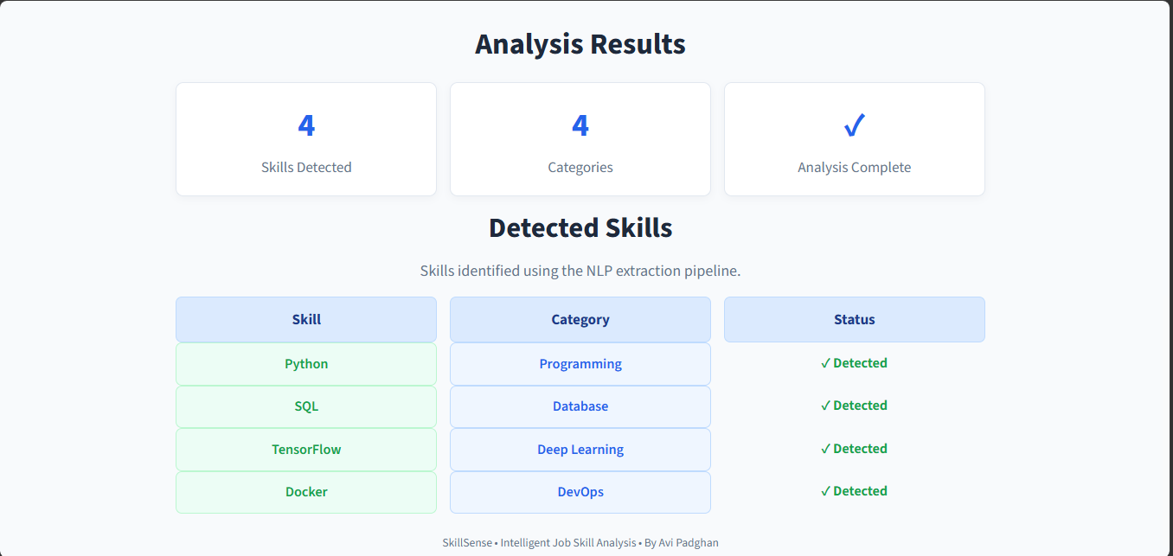20.4 Validation
The extracted results were validated by comparing the system output with the expected skills present in the input job descriptions. Model performance was also evaluated using standard metrics such as Precision, Recall, F1-Score, and Accuracy.
For the implemented TF-IDF + Logistic Regression classification approach, the obtained accuracy was 21.43%, with Precision of 2%, Recall of 10%, and F1-Score of 4%.
20.5 Final Results
The final system successfully demonstrates an end-to-end job-skill analysis workflow:
Job Description → NLP Processing → Skill Extraction → Normalization → Structured Output
The developed application provides a practical interface for extracting and analyzing skills from job descriptions. The project also demonstrates the use of NLP, transformer-based techniques, machine learning, visualization, and dashboard-based analytics for job-market skill analysis.
Metric | Result
Accuracy | 21.43%
Precision | 2%
Recall | 10%
F1-Score | 4%

21. CHALLENGES & LIMITATIONS

21.1 Problems Faced
During the development of SkillSense, several challenges were encountered while working with job-description data and NLP models.
- Job descriptions contain different formats and writing styles.
- The same skill may appear using different names or abbreviations.
- Multi-word skills can be difficult to identify correctly.
- Some text may contain unnecessary or irrelevant information.
- Integrating the NLP model with the Streamlit application required proper input-output handling.
21.2 Model Limitations
The skill extraction model has some limitations:
- The model may produce false positives by identifying non-skill terms as entities.
- Some actual skills may be missed, resulting in false negatives.
- Multi-word skills may sometimes be extracted as partial entities.
- Model performance depends on the quality and coverage of the training data.
- New or uncommon technologies may not always be recognized correctly.
21.3 Dataset Limitations
The dataset also presents certain limitations:
- The dataset contains a limited number of job records compared with the complete job market.
- Skill representation may vary across different job descriptions.
- Some job roles or technologies may be underrepresented.
- Dataset quality directly affects the training and evaluation results.
- The dataset may not cover every newly emerging skill or technology.
21.4 Overall Limitation
The SkillSense system provides automated skill analysis, but its output should be considered supporting information rather than a replacement for human judgment. Improving the dataset, skill taxonomy, normalization rules, and model training can further improve the system's performance.

22. CONCLUSION
The SkillSense – Intelligent Job Skill Analysis project successfully demonstrates the application of Natural Language Processing and Machine Learning techniques for extracting relevant skills from job descriptions.
The project covers the complete workflow from dataset analysis and NLP preprocessing to skill extraction, normalization, model evaluation, web application development, and dashboard visualization. A DistilBERT-based NER approach was used for domain-specific skill identification, while rule-based and TF-IDF-based approaches provided additional methods for text and skill analysis.
The developed Streamlit application provides a user-friendly interface for submitting job descriptions and obtaining structured skill information. The Power BI dashboard further presents job-market insights such as top skills, skill demand by job role, skill categories, and salary analysis.
Key Achievements
- Developed an NLP-based job-skill extraction system.
- Analyzed 4,200+ job records during the project workflow.
- Implemented TF-IDF-based text representation.
- Developed a DistilBERT-based NER approach for skill extraction.
- Applied skill normalization and categorization concepts.
- Evaluated the machine learning approach using standard metrics.
- Developed an interactive Streamlit web application.
- Created a Power BI skill analytics dashboard.
- Identified practical applications in recruitment, skill analysis, and career planning.
Overall, the project demonstrates how NLP, transformer models, machine learning, and data visualization can be combined to convert unstructured job descriptions into structured and meaningful skill insights.

23. FUTURE SCOPE

The SkillSense project can be further extended to provide more advanced recruitment and career-oriented features. The current skill extraction system can serve as a foundation for building intelligent job-matching and recommendation solutions.
23.1 Resume–Job Matching
The system can be extended to compare the skills extracted from a resume with the skills required in a job description. A matching score can be generated to indicate how closely the candidate profile matches the job requirements.
23.2 Candidate Ranking
Multiple candidates can be ranked based on their skills, experience, qualifications, and similarity to the required job profile. This can help recruiters shortlist suitable candidates more efficiently.
23.3 Skill-Gap Analysis
The system can identify the skills required by a job but missing from a candidate's resume. This can help candidates understand their skill gaps and identify areas for improvement.
23.4 Recommendation System
A recommendation system can be developed to suggest:
- Suitable job roles
- Relevant skills to learn
- Learning resources
- Career opportunities
Recommendations can be generated based on the candidate's existing skills and target job requirements.
23.5 Future System Vision
The future version of SkillSense can evolve from a skill extraction system into a complete intelligent career and recruitment platform:
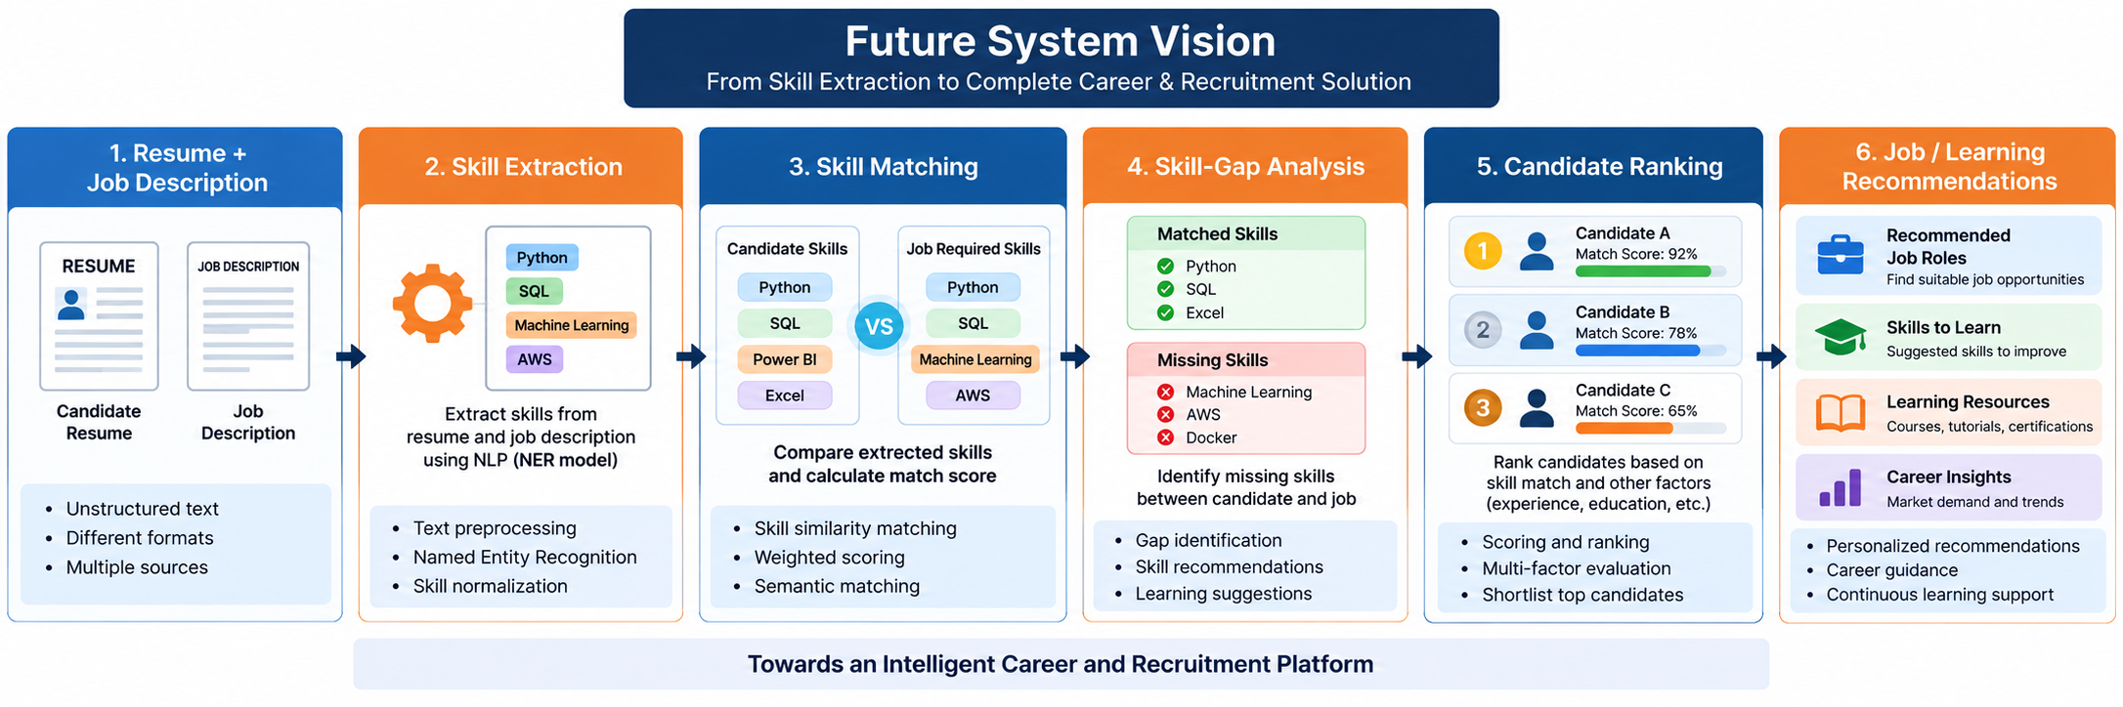These enhancements can make SkillSense more useful for recruiters, job seekers, students, and organizations.

24. INTERNSHIP LEARNING OUTCOMES

During the internship, practical knowledge and hands-on experience were gained in technical development, data analysis, NLP, machine learning, and project development. The project provided an opportunity to apply theoretical concepts to a real-world job-skill extraction problem.
24.1 Technical Skills
- Python programming for NLP and Machine Learning.
- Working with Pandas, NumPy, NLTK, spaCy, Scikit-learn, and Transformers.
- Data preprocessing and text cleaning.
- Working with DistilBERT and NER models.
- Streamlit application development.
- Power BI dashboard development.
- Git and GitHub for project management.
24.2 Analytical Skills
- Performing Exploratory Data Analysis (EDA).
- Analyzing job-market and skill-demand data.
- Identifying patterns across job roles and locations.
- Creating visualizations using Matplotlib and Seaborn.
- Interpreting model evaluation results.
- Drawing meaningful insights from extracted skills.
24.3 NLP Skills
- Text preprocessing and tokenization.
- Understanding stopwords, stemming, and lemmatization.
- TF-IDF and N-Gram analysis.
- Named Entity Recognition (NER).
- Skill extraction from unstructured job descriptions.
- Skill normalization, alias matching, and categorization.
- Working with transformer-based NLP models.
24.4 Machine Learning Skills
- Preparing training and testing data.
- Feature engineering using TF-IDF.
- Implementing Logistic Regression.
- Understanding model training and prediction.
- Evaluating models using Accuracy, Precision, Recall, and F1-Score.
- Performing error analysis and understanding model limitations.
24.5 Project Development Skills
- Developing an end-to-end NLP project.
- Integrating the NLP model with a Streamlit web application.
- Creating an interactive Power BI dashboard.
- Connecting data processing, model, application, and visualization components.
- Debugging and solving implementation issues.
- Preparing technical documentation and project reports.
24.6 Overall Learning Outcome
The internship provided practical experience in applying NLP, Machine Learning, data analysis, and application development to a real-world problem. It improved technical knowledge, analytical thinking, problem-solving ability, and understanding of the complete data → model → application → dashboard development lifecycle.

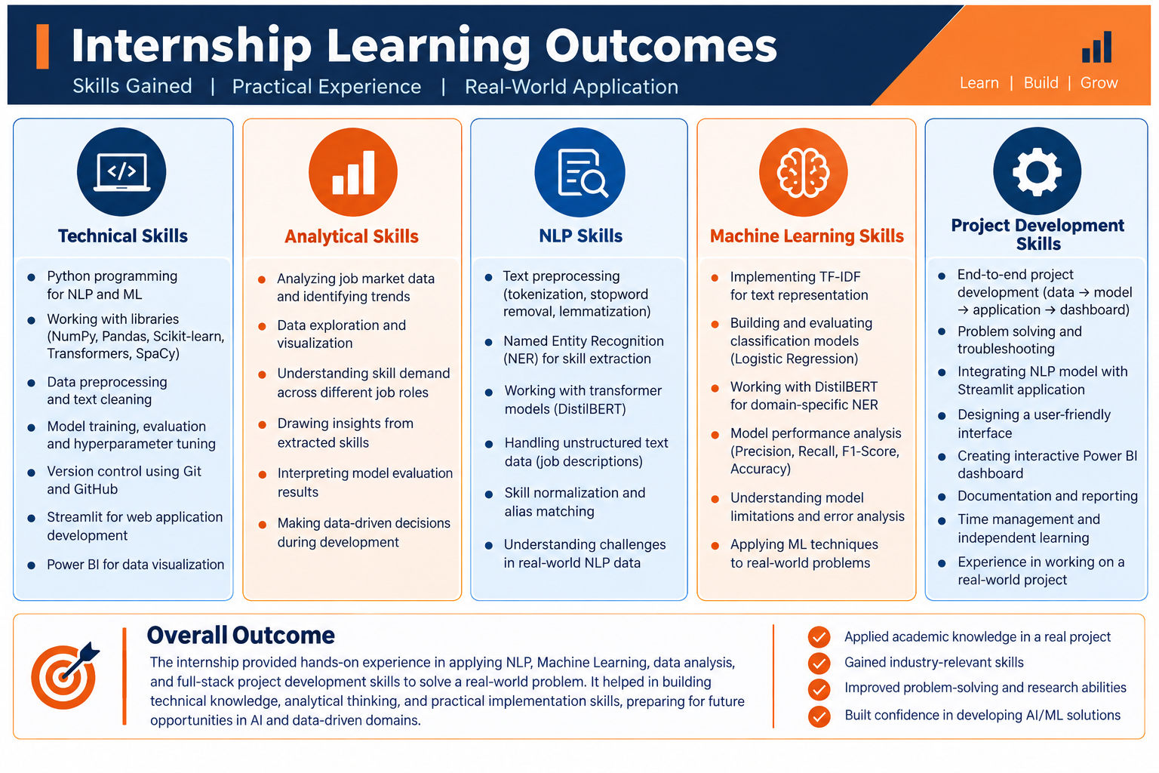

25. REFERENCES

25.1 Dataset Source
- ChatGPT (OpenAI) – Used to assist in generating and structuring the synthetic Job Description dataset used in the SkillSense project.
OpenAI / ChatGPT
25.2 Python Libraries & Documentation
- Python Documentation – Python programming and standard libraries.
Python Documentation
- Pandas Documentation – Data manipulation and analysis.
Pandas Documentation
- NumPy Documentation – Numerical computing and array operations.
NumPy Documentation
- NLTK Documentation – Natural Language Processing and text preprocessing.
NLTK Documentation
- spaCy Documentation – NLP processing and linguistic analysis.
spaCy Documentation
- Scikit-learn Documentation – Machine learning, TF-IDF, Logistic Regression and model evaluation.
Scikit-learn Documentation
- Hugging Face Transformers Documentation – Transformer models, tokenization, training and inference.
Hugging Face Transformers Documentation
- Matplotlib Documentation – Data visualization and plotting.
Matplotlib Documentation
- Seaborn Documentation – Statistical data visualization.
Seaborn Documentation
25.3 Tools & Platforms
- Streamlit Documentation – Interactive web application development.
Streamlit Documentation
- Microsoft Power BI Documentation – Dashboard and data visualization.
Power BI Documentation
- Project Jupyter Documentation – Interactive notebooks and data analysis.
Jupyter Documentation
- GitHub Documentation – Version control and project development resources.
GitHub Documentation
25.4 Research Papers
- Devlin, J., Chang, M.-W., Lee, K., & Toutanova, K.
BERT: Pre-training of Deep Bidirectional Transformers for Language Understanding.
BERT Research Paper
- Sanh, V., Debut, L., Chaumond, J., & Wolf, T.
DistilBERT, a distilled version of BERT: smaller, faster, cheaper and lighter.
DistilBERT Research Paper
- Vaswani, A., et al.
Attention Is All You Need.
Transformer Research Paper

